

CAPSTONE PROJECT REPORT
Report 4 – Software Design Specification

– Hanoi, Aug 2026 –

Table of Contents
Change Log 3
I. High Level Design 4
1. Software Architecture 4
2. Package Diagram 6
3. Database Design 7
3.1 chains 8
3.2 locations 9
3.3 room_types 9
3.4 rooms 9
3.5 assets 9
3.6 users 10
3.7 refresh_tokens 10
3.8 staff_location_assignments 10
3.9 staff_employments 11
3.10 schedule_plans 11
3.11 shifts 12
3.12 operational_tasks 12
3.13 residents 13
3.14 contracts 13
3.15 contract_signings 13
3.16 security_deposits 14
3.17 contract_residents 14
3.18 room_inspections 15
3.19 temporary_residence_tasks 15
3.20 billing_policies 16
3.21 meters 16
3.3 table_name3 19
II. Detailed Code Design 19
1. <Feature/Function Name1> 20
1.1 Class Diagram 20
1.2 <Sequence Diagram Name1> 20
1.3 <Sequence Diagram Name2> 20
2. <Feature/Function Name2> 20
1. Location Setup and Configuration 21
1.1 Class Diagram 21
1.2 Create Location and Initial Configuration 22
1.3 Update / Remove Location Configuration 23
3. Main Tenancy Contract Creation and Activation 24
3.1 Class Diagram 24
3.2 Main Tenancy Contract Creation and Activation Sequence Diagram 24
4.Contract Termination and Move-out Settlement 25
4.1 Contract Termination and Move-out Settlement Sequence Diagram 25
5. Meter Reading, Billing and Payment Management 27
5.1 Class Diagram 27
5.2 Meter Reading and Invoice Cycle Sequence Diagram 29
5.3 Bank Payment, Debt and Invoice Adjustment Sequence Diagram 30
6. Incident and Maintenance Management 31
6.1 Class Diagram 31
6.1.1 Incident Reporting and Emergency Response 31
6.1.2 Maintenance Verification and Cost Recording 31
6.2 Sequence Diagram 32
6.2.1 Submit Incident Report 32
6.2.2 Acknowledge and Record Emergency Action 33
6.2.3 Verify Work Order and Resolve Incident 34
1. Security Design 36
1.1 Authentication Flow 36
1.2 Authorization & RBAC Implementation 37
1.3 Data Protection 37
2. Performance & Scalability Design 38
2.1 Caching Strategy 38
2.2 Database Query Optimization 39
2.3 Background Processing 39
3. Reliability & Recoverability Design 39
3.1 Integration Failure Handling 39
3.2 Data Consistency & Recovery 40
4. Privacy & Test Data Design 40
5. Usability Design 41
IV. Other Design Specifications 42

Change Log
Date | A*  M, D | In charge | Change Description
*A - Added M - Modified D - Deleted

I. High Level Design

1. Software Architecture
BHOME uses a layered architecture with three client applications communicating with a centralized ASP.NET Core 8 Web API through HTTPS/REST/JSON.
The Owner Web Portal is the main management interface for configuration, staff, contracts, billing, finance, reporting, and business analysis. The BHOME Mobile App supports Owner monitoring and quick actions, Staff daily operations, and Tenant self-service. The Public Website provides approved public Location and Room information to Guests.
The backend handles authentication and authorization, receives API requests through the Controller Layer, and processes business rules in the Service Layer. Internal OCR assists meter and CCCD data capture, while Background Jobs handle scheduled activities such as invoice generation, reminders, retries, and recurring tasks.
Business data is stored in PostgreSQL through Entity Framework Core. Images, contracts, and evidence files are stored in MinIO/S3-compatible Object Storage.
BHOME also integrates with external services for bank-payment reconciliation, push/email notifications, and electronic contract signing.
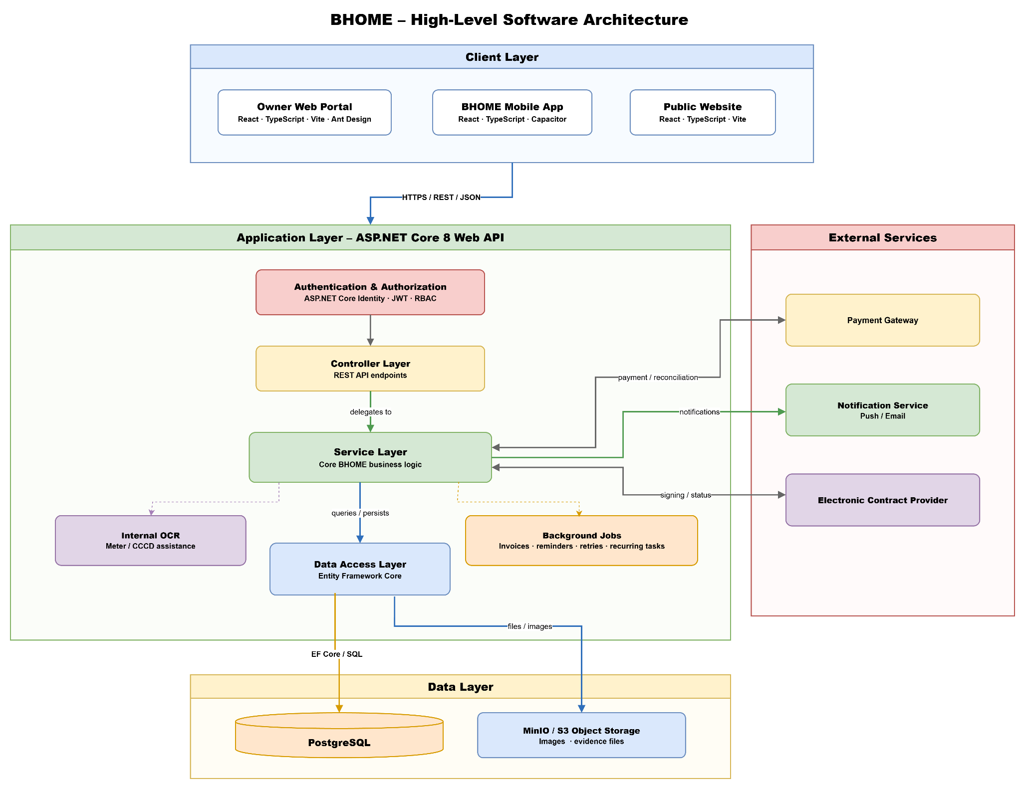
Architecture component descriptions
No | Component | Description
Client Layer
1 | Owner Web Portal | Main web interface for Owner configuration, management, finance, reporting, and business analysis.
2 | BHOME Mobile App | Mobile interface for Owner monitoring, Staff operations, and Tenant self-service.
3 | Public Website | Public information channel where Guests can view approved Location, Room, vacancy, pricing, and contact information.
Application Layer
1 | Authentication & Authorization | Authenticates users and enforces Owner, Staff, and Tenant access permissions using Identity, JWT, and RBAC.
2 | Controller Layer | Receives REST API requests, validates input, and forwards requests to the appropriate business service.
3 | Service Layer | Contains the main BHOME business logic and coordinates system workflows.
4 | Internal OCR | Assists in extracting meter readings and CCCD information; proposed values must be confirmed before official use.
5 | Background Jobs | Executes scheduled processes such as invoice generation, reminders, retries, and recurring operational tasks.
6 | Data Access Layer | Uses Entity Framework Core to read and write application data.
Data Layer
1 | PostgreSQL | Stores structured BHOME business data such as users, rooms, contracts, invoices, payments, and operational records.
2 | MinIO / S3 Object Storage | Stores files such as meter images, contract documents, and incident or maintenance evidence.
External Services
1 | Payment Gateway | Provides bank-transfer transaction data for automatic or manual payment reconciliation.
2 | Notification Service | Delivers supported push notifications and emails to BHOME users.
3 | Electronic Contract Provider | Supports electronic contract signing and returns signing status and evidence to BHOME.

2. Package Diagram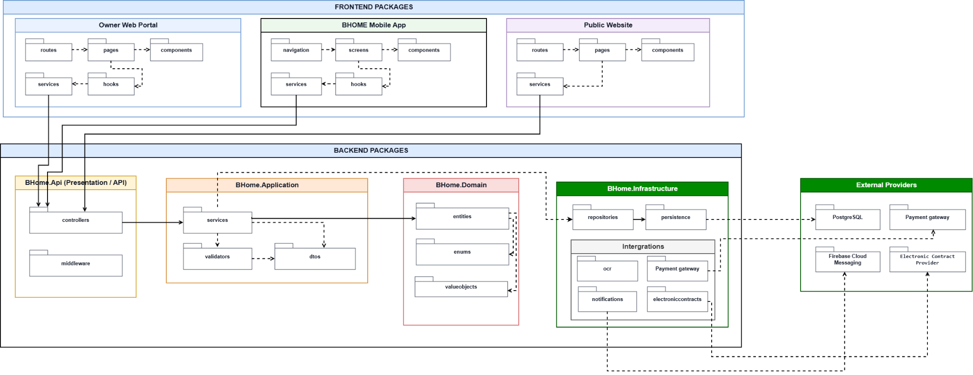
Package descriptions

No | Package | Description
1 | routes | Defines navigation routes for the Owner Web Portal and maps URLs to corresponding pages.
2 | pages | Contains page-level components of the Owner Web Portal, such as dashboard, contract management, room management, and financial management pages.
3 | components | Contains reusable UI components shared across Owner Web Portal pages.
4 | services | Handles API communication between the Owner Web Portal and the BHOME backend.
5 | navigation | Defines the navigation structure and screen transitions of the BHOME Mobile Application.
6 | screens | Contains application screens used by Owner, Staff, and Tenant.
7 | components | Contains reusable UI components shared between Mobile Application screens.
8 | services | Handles REST API communication between the Mobile Application and the BHOME backend.
9 | routes | Defines routes for the BHOME Public Website and maps public URLs to corresponding pages.
10 | pages | Contains page-level components used to display public Location, Room,
11 | components | Contains reusable UI components for the Public Website.
12 | services | Handles API communication for retrieving approved public information from the BHOME backend.
13 | controllers | Exposes REST API endpoints and handles incoming HTTP requests from frontend applications.
14 | middleware | Handles cross-cutting HTTP processing such as authentication, authorization, exception handling, and request processing.
15 | usecases | Implements application-level business workflows and coordinates Domain and Infrastructure components.
16 | dto | Contains Data Transfer Objects used to transfer request and response data between layers.
17 | validators | Contains validation rules for application requests before business processing.
18 | entities | Contains the core BHOME business entities, such as Contract, Room, Tenant, Invoice, and Payment.
19 | interfaces | Defines abstractions used by the Application and Domain layers.
20 | persistence | Handles database access, repository implementations, and persistence configuration.
21 | storage | Handles file, image, document, and evidence storage.
22 | ocr | Handles internal OCR processing for assisted data capture, especially electricity and water meter readings.
23 | banking | Handles bank transaction integration and payment reconciliation.
24 | notification | Handles push notification and email delivery.
25 | electronic contracts | Handles integration with the external Electronic Contract Provider, including contract submission and signing-status retrieval.

3. Database Design
BHOME stores all business data in a single PostgreSQL 16 database accessed through Entity Framework Core. The physical design has 39 tables in 6 modules, linked by 99 foreign keys; files such as contracts, meter photos and incident evidence are stored in MinIO, and the database keeps only their object keys.
The design follows the business flows in Report 3: a chain owns Locations, Locations own Room Types and Rooms, a Room is rented through Contracts, Contracts drive meter readings, Invoices and Payments, and Rooms and Assets are the subject of incidents, maintenance and operating costs.
Figure 3.1 shows the Overall ERD; Figures 3.2–3.7 show one ERD per module with the related tables of other modules for context. The diagrams use crow's foot notation: the crow's foot is on the table that holds the foreign key (many sides) and the bar is on the referenced table (one side); a dashed loop marks a self-reference.
To keep the Overall ERD readable, 27 relationships to users that only record who created, assigned, verified or decided a record (for example created_by_user_id, verified_by_user_id) are not drawn; each remains a foreign key column in its table and is shown in the module ERDs.
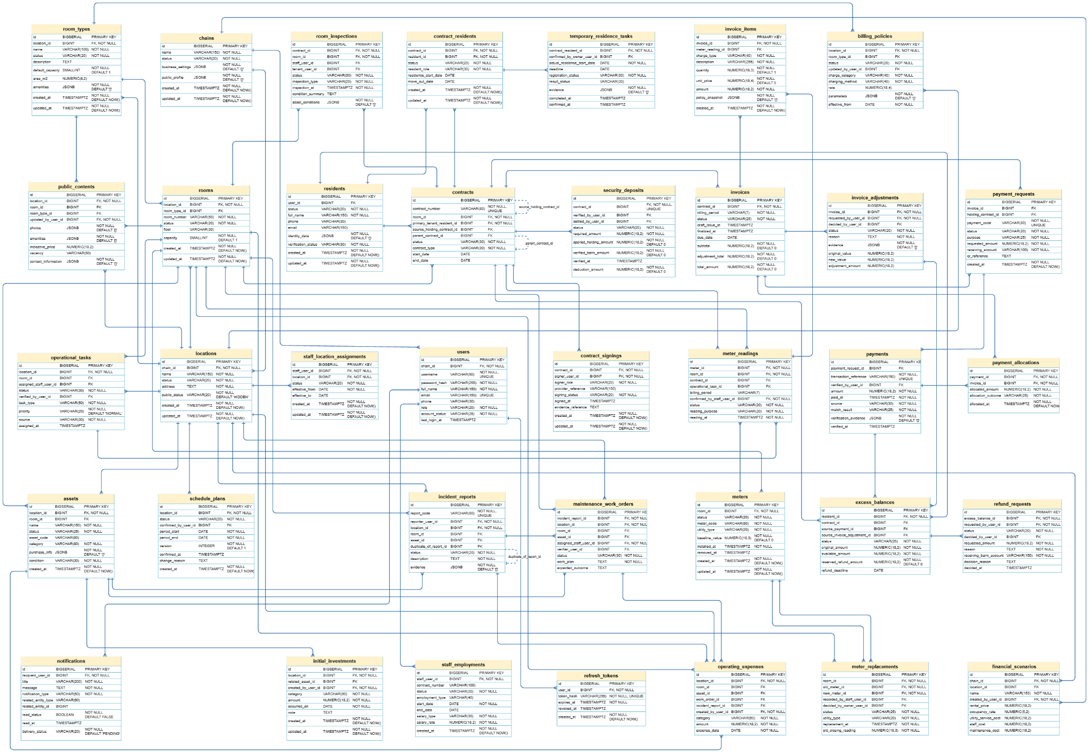

3.1 chains
Column | Type | Constraints | Notes
id | BIGSERIAL | PRIMARY KEY | Auto-increment
name | VARCHAR(150) | NOT NULL
business_settings | JSONB | NOT NULL DEFAULT '{}' | Chain-wide settings (billing day, reminders, defaults)
public_profile | JSONB | NOT NULL DEFAULT '{}' | Business name, logo and contact shown on the Public Website
status | VARCHAR(20) | NOT NULL | Lifecycle status; allowed values and transitions checked in the Service layer
created_at | TIMESTAMPTZ | NOT NULL DEFAULT NOW() | Set when the record is created

3.2 locations
Column | Type | Constraints | Notes
id | BIGSERIAL | PRIMARY KEY | Auto-increment
chain_id | BIGINT | FK, NOT NULL | → chains.id
name | VARCHAR(150) | NOT NULL
address | TEXT | NOT NULL | Full address of the building
public_status | VARCHAR(20) | NOT NULL DEFAULT 'HIDDEN' | HIDDEN until the Owner publishes the Location
status | VARCHAR(20) | NOT NULL | Lifecycle status; allowed values and transitions checked in the Service layer
created_at | TIMESTAMPTZ | NOT NULL DEFAULT NOW() | Set when the record is created

3.3 room_types
Column | Type | Constraints | Notes
id | BIGSERIAL | PRIMARY KEY | Auto-increment
location_id | BIGINT | FK, NOT NULL | → locations.id
name | VARCHAR(100) | NOT NULL
description | TEXT
default_capacity | SMALLINT | NOT NULL DEFAULT 1 | Default number of occupants for rooms of this type
area_m2 | NUMERIC(8,2)
amenities | JSONB | NOT NULL DEFAULT '[]' | List of amenities (air-con, balcony…)
status | VARCHAR(20) | NOT NULL | Lifecycle status; allowed values and transitions checked in the Service layer
created_at | TIMESTAMPTZ | NOT NULL DEFAULT NOW() | Set when the record is created
updated_at | TIMESTAMPTZ | NOT NULL DEFAULT NOW() | Updated on every change

3.4 rooms
Column | Type | Constraints | Notes
id | BIGSERIAL | PRIMARY KEY | Auto-increment
location_id | BIGINT | FK, NOT NULL | → locations.id
room_type_id | BIGINT | FK | → room_types.id; optional, a room may have no type
room_number | VARCHAR(50) | NOT NULL | Unique within the Location
floor | VARCHAR(30)

3.5 assets
Column | Type | Constraints | Notes
id | BIGSERIAL | PRIMARY KEY | Auto-increment
location_id | BIGINT | FK, NOT NULL | → locations.id
room_id | BIGINT | FK | → rooms.id; empty for shared assets of the Location
asset_code | VARCHAR(80)
name | VARCHAR(150) | NOT NULL
category | VARCHAR(80) | NOT NULL
purchase_info | JSONB | NOT NULL DEFAULT '{}' | Supplier, price, purchase date, warranty
condition | VARCHAR(30) | NOT NULL | Current condition; updated by inspections and maintenance
status | VARCHAR(25) | NOT NULL | In use, needs repair, under repair, retired
created_at | TIMESTAMPTZ | NOT NULL DEFAULT NOW() | Set when the record is created
updated_at | TIMESTAMPTZ | NOT NULL DEFAULT NOW() | Updated on every change

3.6 users
Column | Type | Constraints | Notes
id | BIGSERIAL | PRIMARY KEY | Auto-increment
chain_id | BIGINT | FK, NOT NULL | → chains.id
username | VARCHAR(50) | NOT NULL, UNIQUE | Login identifier
password_hash | VARCHAR(255) | NOT NULL | Hash produced by ASP.NET Core Identity; never plaintext
full_name | VARCHAR(150) | NOT NULL
email | VARCHAR(150) | UNIQUE | Optional; unique when present
phone | VARCHAR(30)
role | VARCHAR(20) | NOT NULL | OWNER, STAFF or TENANT
account_status | VARCHAR(25) | NOT NULL | Active, locked or deactivated; non-active accounts cannot sign in
last_login_at | TIMESTAMPTZ |  | Time of the last successful sign-in
created_at | TIMESTAMPTZ | NOT NULL DEFAULT NOW() | Set when the record is created
updated_at | TIMESTAMPTZ | NOT NULL DEFAULT NOW() | Updated on every change

3.7 refresh_tokens
Column | Type | Constraints | Notes
id | BIGSERIAL | PRIMARY KEY | Auto-increment
user_id | BIGINT | FK, NOT NULL | → users.id
token_hash | VARCHAR(255) | NOT NULL, UNIQUE | Hash of the refresh token; the raw token is only on the device
expires_at | TIMESTAMPTZ | NOT NULL
revoked_at | TIMESTAMPTZ |  | Set on logout, password change or account deactivation
created_at | TIMESTAMPTZ | NOT NULL DEFAULT NOW() | Set when the record is created

3.8 staff_location_assignments
Column | Type | Constraints | Notes
id | BIGSERIAL | PRIMARY KEY | Auto-increment
staff_user_id | BIGINT | FK, NOT NULL | → users.id (Staff)
location_id | BIGINT | FK, NOT NULL | → locations.id
effective_from | DATE | NOT NULL
effective_to | DATE |  | Empty while the assignment is open-ended
status | VARCHAR(20) | NOT NULL | Lifecycle status; allowed values and transitions checked in the Service layer
created_at | TIMESTAMPTZ | NOT NULL DEFAULT NOW() | Set when the record is created
updated_at | TIMESTAMPTZ | NOT NULL DEFAULT NOW() | Updated on every change

3.9 staff_employments
Column | Type | Constraints | Notes
id | BIGSERIAL | PRIMARY KEY | Auto-increment
staff_user_id | BIGINT | FK, NOT NULL | → users.id
contract_number | VARCHAR(100)
employment_type | VARCHAR(40)
start_date | DATE | NOT NULL
end_date | DATE
salary_type | VARCHAR(30) | NOT NULL | Monthly, hourly or per-shift
salary_rate | NUMERIC(18,2) | NOT NULL | Amount in VND per salary unit
status | VARCHAR(20) | NOT NULL | Lifecycle status; allowed values and transitions checked in the Service layer
created_at | TIMESTAMPTZ | NOT NULL DEFAULT NOW() | Set when the record is created
updated_at | TIMESTAMPTZ | NOT NULL DEFAULT NOW() | Updated on every change

3.10 schedule_plans
Column | Type | Constraints | Notes
id | BIGSERIAL | PRIMARY KEY | Auto-increment
location_id | BIGINT | FK, NOT NULL | → locations.id
period_start | DATE | NOT NULL
period_end | DATE | NOT NULL
version | INTEGER | NOT NULL DEFAULT 1 | Incremented on each re-confirmed change
status | VARCHAR(20) | NOT NULL | Lifecycle status; allowed values and transitions checked in the Service layer
confirmed_by_user_id | BIGINT | FK | → users.id (Owner who confirmed the schedule)
confirmed_at | TIMESTAMPTZ
change_reason | TEXT |  | Required when a confirmed schedule is changed
created_at | TIMESTAMPTZ | NOT NULL DEFAULT NOW() | Set when the record is created
updated_at | TIMESTAMPTZ | NOT NULL DEFAULT NOW() | Updated on every change

3.11 shifts
Column | Type | Constraints | Notes
id | BIGSERIAL | PRIMARY KEY | Auto-increment
schedule_plan_id | BIGINT | FK, NOT NULL | → schedule_plans.id
location_id | BIGINT | FK, NOT NULL | → locations.id
staff_user_id | BIGINT | FK, NOT NULL | → users.id
planned_start | TIMESTAMPTZ | NOT NULL
planned_end | TIMESTAMPTZ | NOT NULL
actual_start | TIMESTAMPTZ |  | Recorded at check-in
actual_end | TIMESTAMPTZ |  | Recorded at check-out
source | VARCHAR(30) | NOT NULL DEFAULT 'OWNER' | OWNER when planned by the Owner; other values for swaps
change_reason | TEXT
status | VARCHAR(20) | NOT NULL | Lifecycle status; allowed values and transitions checked in the Service layer
created_at | TIMESTAMPTZ | NOT NULL DEFAULT NOW() | Set when the record is created
updated_at | TIMESTAMPTZ | NOT NULL DEFAULT NOW() | Updated on every change

3.12 operational_tasks
Column | Type | Constraints | Notes
id | BIGSERIAL | PRIMARY KEY | Auto-increment
location_id | BIGINT | FK, NOT NULL | → locations.id
room_id | BIGINT | FK | → rooms.id
assigned_staff_user_id | BIGINT | FK | → users.id
task_type | VARCHAR(50) | NOT NULL | Meter reading, inspection, handover, cleaning, maintenance…
priority | VARCHAR(20) | NOT NULL DEFAULT 'NORMAL' | NORMAL by default; URGENT for emergencies
source | VARCHAR(30) | NOT NULL | Who or what created the task (Owner, schedule, system job)
assigned_at | TIMESTAMPTZ
due_at | TIMESTAMPTZ
progress_note | TEXT
evidence | JSONB | NOT NULL DEFAULT '[]' | MinIO object keys of photos
status | VARCHAR(30) | NOT NULL | Lifecycle status; allowed values and transitions checked in the Service layer
verified_by_user_id | BIGINT | FK | → users.id (Owner who verified the result)
verified_at | TIMESTAMPTZ
created_at | TIMESTAMPTZ | NOT NULL DEFAULT NOW() | Set when the record is created
updated_at | TIMESTAMPTZ | NOT NULL DEFAULT NOW() | Updated on every change

3.13 residents
Column | Type | Constraints | Notes
id | BIGSERIAL | PRIMARY KEY | Auto-increment
user_id | BIGINT | FK | → users.id; empty until the resident has an app account
full_name | VARCHAR(150) | NOT NULL
phone | VARCHAR(30)
email | VARCHAR(150)
identity_data | JSONB | NOT NULL DEFAULT '{}' | CCCD fields confirmed by Staff; CCCD images are not kept
verification_status | VARCHAR(30) | NOT NULL | Identity verification state (pending, verified, rejected)
status | VARCHAR(20) | NOT NULL | Lifecycle status; allowed values and transitions checked in the Service layer
created_at | TIMESTAMPTZ | NOT NULL DEFAULT NOW() | Set when the record is created
updated_at | TIMESTAMPTZ | NOT NULL DEFAULT NOW() | Updated on every change

3.14 contracts
Column | Type | Constraints | Notes
id | BIGSERIAL | PRIMARY KEY | Auto-increment
contract_number | VARCHAR(80) | NOT NULL, UNIQUE | Business code shown on documents
contract_type | VARCHAR(30) | NOT NULL | HOLDING or MAIN
room_id | BIGINT | FK, NOT NULL | → rooms.id
primary_tenant_resident_id | BIGINT | FK, NOT NULL | → residents.id (main tenant who signs)
source_holding_contract_id | BIGINT | FK | → contracts.id; holding Contract converted into this main Contract
parent_contract_id | BIGINT | FK | → contracts.id; previous Contract when this one is a renewal
start_date | DATE
end_date | DATE
holding_expiry_at | TIMESTAMPTZ |  | Holding Contract expires if no main Contract is signed by this time
monthly_rent | NUMERIC(18,2) |  | Agreed rent in VND
recurring_terms | JSONB | NOT NULL DEFAULT '{}' | Billing day, included services and other recurring terms
status | VARCHAR(30) | NOT NULL | Draft, pending signing, active, expired, terminated…
created_at | TIMESTAMPTZ | NOT NULL DEFAULT NOW() | Set when the record is created
updated_at | TIMESTAMPTZ | NOT NULL DEFAULT NOW() | Updated on every change

3.15 contract_signings
Column | Type | Constraints | Notes
id | BIGSERIAL | PRIMARY KEY | Auto-increment
contract_id | BIGINT | FK, NOT NULL | → contracts.id
signer_user_id | BIGINT | FK, NOT NULL | → users.id
signer_role | VARCHAR(20) | NOT NULL | OWNER or TENANT
provider_reference | VARCHAR(150) |  | Session or document ID at the e-contract provider
signing_status | VARCHAR(20) | NOT NULL | Pending, signed, rejected or expired at the provider
signed_at | TIMESTAMPTZ
evidence_reference | TEXT |  | Signed-document reference returned by the provider
created_at | TIMESTAMPTZ | NOT NULL DEFAULT NOW() | Set when the record is created
updated_at | TIMESTAMPTZ | NOT NULL DEFAULT NOW() | Updated on every change

3.16 security_deposits
Column | Type | Constraints | Notes
id | BIGSERIAL | PRIMARY KEY | Auto-increment
contract_id | BIGINT | FK, NOT NULL, UNIQUE | → contracts.id; one deposit per Contract
required_amount | NUMERIC(18,2) | NOT NULL
applied_holding_amount | NUMERIC(18,2) | NOT NULL DEFAULT 0 | Holding money moved into the deposit
verified_bank_amount | NUMERIC(18,2) | NOT NULL DEFAULT 0 | Amount confirmed against the bank transaction
verified_by_user_id | BIGINT | FK | → users.id
verified_at | TIMESTAMPTZ
deduction_amount | NUMERIC(18,2) | NOT NULL DEFAULT 0 | Deducted at move-out for damage or debt
deduction_reason | TEXT
refundable_amount | NUMERIC(18,2) | NOT NULL DEFAULT 0 | Amount returned to the tenant at settlement
settled_by_user_id | BIGINT | FK | → users.id (Owner who settled the deposit)
settled_at | TIMESTAMPTZ
status | VARCHAR(20) | NOT NULL | Lifecycle status; allowed values and transitions checked in the Service layer
created_at | TIMESTAMPTZ | NOT NULL DEFAULT NOW() | Set when the record is created
updated_at | TIMESTAMPTZ | NOT NULL DEFAULT NOW() | Updated on every change

3.17 contract_residents
Column | Type | Constraints | Notes
id | BIGSERIAL | PRIMARY KEY | Auto-increment
contract_id | BIGINT | FK, NOT NULL | → contracts.id
resident_id | BIGINT | FK, NOT NULL | → residents.id
resident_role | VARCHAR(30) | NOT NULL | PRIMARY_TENANT or OCCUPANT
residence_start_date | DATE
move_out_date | DATE |  | Set when the occupant leaves
status | VARCHAR(20) | NOT NULL | Lifecycle status; allowed values and transitions checked in the Service layer
created_at | TIMESTAMPTZ | NOT NULL DEFAULT NOW() | Set when the record is created
updated_at | TIMESTAMPTZ | NOT NULL DEFAULT NOW() | Updated on every change

3.18 room_inspections
 | Column | Type | Constraints | Notes
id | BIGSERIAL | PRIMARY KEY | Auto-increment | id
contract_id | BIGINT | FK, NOT NULL | → contracts.id | contract_id
room_id | BIGINT | FK, NOT NULL | → rooms.id | room_id
inspection_type | VARCHAR(20) | NOT NULL | MOVE_IN or MOVE_OUT | inspection_type
inspection_at | TIMESTAMPTZ | NOT NULL |  | inspection_at
condition_summary | TEXT |  |  | condition_summary
asset_conditions | JSONB | NOT NULL DEFAULT '[]' | Condition of each asset at the inspection | asset_conditions
evidence | JSONB | NOT NULL DEFAULT '[]' | MinIO object keys of inspection photos | evidence
staff_user_id | BIGINT | FK | → users.id | staff_user_id
tenant_user_id | BIGINT | FK | → users.id (tenant who confirms the result) | tenant_user_id
status | VARCHAR(30) | NOT NULL | Lifecycle status; allowed values and transitions checked in the Service layer | status
created_at | TIMESTAMPTZ | NOT NULL DEFAULT NOW() | Set when the record is created | created_at
updated_at | TIMESTAMPTZ | NOT NULL DEFAULT NOW() | Updated on every change | updated_at

3.19 temporary_residence_tasks
Column | Type | Constraints | Notes
id | BIGSERIAL | PRIMARY KEY | Auto-increment
contract_resident_id | BIGINT | FK, NOT NULL | → contract_residents.id
actual_residence_start_date | DATE | NOT NULL
deadline | DATE |  | Legal deadline for temporary-residence registration
registration_status | VARCHAR(30) | NOT NULL
result_status | VARCHAR(30)
evidence | JSONB | NOT NULL DEFAULT '[]' | MinIO object keys of the registration proof
completed_at | TIMESTAMPTZ
confirmed_by_owner_user_id | BIGINT | FK | → users.id (Owner who confirms completion)
confirmed_at | TIMESTAMPTZ
created_at | TIMESTAMPTZ | NOT NULL DEFAULT NOW() | Set when the record is created
updated_at | TIMESTAMPTZ | NOT NULL DEFAULT NOW() | Updated on every change

3.20 billing_policies
Column | Type | Constraints | Notes
id | BIGSERIAL | PRIMARY KEY | Auto-increment
location_id | BIGINT | FK, NOT NULL | → locations.id
room_type_id | BIGINT | FK | → room_types.id; empty = applies to the whole Location
charge_category | VARCHAR(40) | NOT NULL | Rent, electricity, water, internet, service…
charging_method | VARCHAR(40) | NOT NULL | Per unit, fixed per room, per person or tiered
rate | NUMERIC(18,4) |  | Unit price in VND
parameters | JSONB | NOT NULL DEFAULT '{}' | Extra settings such as tiers or free quota
effective_from | DATE | NOT NULL
effective_to | DATE
version | INTEGER | NOT NULL DEFAULT 1 | New version on each change; old Invoices keep their snapshot
status | VARCHAR(20) | NOT NULL | Lifecycle status; allowed values and transitions checked in the Service layer
updated_by_user_id | BIGINT | FK | → users.id
created_at | TIMESTAMPTZ | NOT NULL DEFAULT NOW() | Set when the record is created
updated_at | TIMESTAMPTZ | NOT NULL DEFAULT NOW() | Updated on every change

3.21 meters
Column | Type | Constraints | Notes

Column | Type | Constraints | Notes
id | BIGSERIAL | PRIMARY KEY | Auto-increment
username | VARCHAR(50) | NOT NULL, UNIQUE | Login identifier; [a-zA-Z0-9_] only
password_hash | VARCHAR(60) | NOT NULL | BCrypt hash; never store plaintext
full_name | VARCHAR(100) | NOT NULL
email | VARCHAR(100) | NOT NULL, UNIQUE
…

Column | Type | Constraints | Notes
id | BIGSERIAL | PRIMARY KEY | Auto-increment
username | VARCHAR(50) | NOT NULL, UNIQUE | Login identifier; [a-zA-Z0-9_] only
password_hash | VARCHAR(60) | NOT NULL | BCrypt hash; never store plaintext
full_name | VARCHAR(100) | NOT NULL
email | VARCHAR(100) | NOT NULL, UNIQUE
…

Column | Type | Constraints | Notes
id | BIGSERIAL | PRIMARY KEY | Auto-increment
username | VARCHAR(50) | NOT NULL, UNIQUE | Login identifier; [a-zA-Z0-9_] only
password_hash | VARCHAR(60) | NOT NULL | BCrypt hash; never store plaintext
full_name | VARCHAR(100) | NOT NULL
email | VARCHAR(100) | NOT NULL, UNIQUE
…

Column | Type | Constraints | Notes
id | BIGSERIAL | PRIMARY KEY | Auto-increment
username | VARCHAR(50) | NOT NULL, UNIQUE | Login identifier; [a-zA-Z0-9_] only
password_hash | VARCHAR(60) | NOT NULL | BCrypt hash; never store plaintext
full_name | VARCHAR(100) | NOT NULL
email | VARCHAR(100) | NOT NULL, UNIQUE
…

Column | Type | Constraints | Notes
id | BIGSERIAL | PRIMARY KEY | Auto-increment
username | VARCHAR(50) | NOT NULL, UNIQUE | Login identifier; [a-zA-Z0-9_] only
password_hash | VARCHAR(60) | NOT NULL | BCrypt hash; never store plaintext
full_name | VARCHAR(100) | NOT NULL
email | VARCHAR(100) | NOT NULL, UNIQUE
…

Column | Type | Constraints | Notes
id | BIGSERIAL | PRIMARY KEY | Auto-increment
username | VARCHAR(50) | NOT NULL, UNIQUE | Login identifier; [a-zA-Z0-9_] only
password_hash | VARCHAR(60) | NOT NULL | BCrypt hash; never store plaintext
full_name | VARCHAR(100) | NOT NULL
email | VARCHAR(100) | NOT NULL, UNIQUE
…

Column | Type | Constraints | Notes
id | BIGSERIAL | PRIMARY KEY | Auto-increment
username | VARCHAR(50) | NOT NULL, UNIQUE | Login identifier; [a-zA-Z0-9_] only
password_hash | VARCHAR(60) | NOT NULL | BCrypt hash; never store plaintext
full_name | VARCHAR(100) | NOT NULL
email | VARCHAR(100) | NOT NULL, UNIQUE
…

Column | Type | Constraints | Notes
id | BIGSERIAL | PRIMARY KEY | Auto-increment
username | VARCHAR(50) | NOT NULL, UNIQUE | Login identifier; [a-zA-Z0-9_] only
password_hash | VARCHAR(60) | NOT NULL | BCrypt hash; never store plaintext
full_name | VARCHAR(100) | NOT NULL
email | VARCHAR(100) | NOT NULL, UNIQUE
…

Column | Type | Constraints | Notes
id | BIGSERIAL | PRIMARY KEY | Auto-increment
username | VARCHAR(50) | NOT NULL, UNIQUE | Login identifier; [a-zA-Z0-9_] only
password_hash | VARCHAR(60) | NOT NULL | BCrypt hash; never store plaintext
full_name | VARCHAR(100) | NOT NULL
email | VARCHAR(100) | NOT NULL, UNIQUE
…

Column | Type | Constraints | Notes
id | BIGSERIAL | PRIMARY KEY | Auto-increment
username | VARCHAR(50) | NOT NULL, UNIQUE | Login identifier; [a-zA-Z0-9_] only
password_hash | VARCHAR(60) | NOT NULL | BCrypt hash; never store plaintext
full_name | VARCHAR(100) | NOT NULL
email | VARCHAR(100) | NOT NULL, UNIQUE
…

Column | Type | Constraints | Notes
id | BIGSERIAL | PRIMARY KEY | Auto-increment
username | VARCHAR(50) | NOT NULL, UNIQUE | Login identifier; [a-zA-Z0-9_] only
password_hash | VARCHAR(60) | NOT NULL | BCrypt hash; never store plaintext
full_name | VARCHAR(100) | NOT NULL
email | VARCHAR(100) | NOT NULL, UNIQUE
…

Column | Type | Constraints | Notes
id | BIGSERIAL | PRIMARY KEY | Auto-increment
username | VARCHAR(50) | NOT NULL, UNIQUE | Login identifier; [a-zA-Z0-9_] only
password_hash | VARCHAR(60) | NOT NULL | BCrypt hash; never store plaintext
full_name | VARCHAR(100) | NOT NULL
email | VARCHAR(100) | NOT NULL, UNIQUE
…

3.3 table_name3
…

II. Detailed Code Design
[Provide detailed design set for features involving the most integrations with the backend and external services, limit at 2-3 design sets. Each set includes Class Diagram and Sequence Diagram(s)]

1. <Feature/Function Name1>

1.1 Class Diagram
[This part presents the class diagram for the relevant feature]
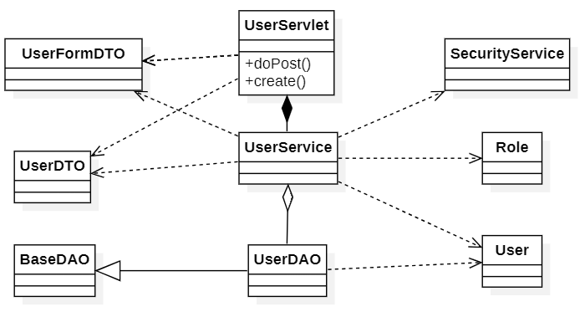

1.2 <Sequence Diagram Name1>
[Provide the sequence diagram(s) for the feature, see the sample below]
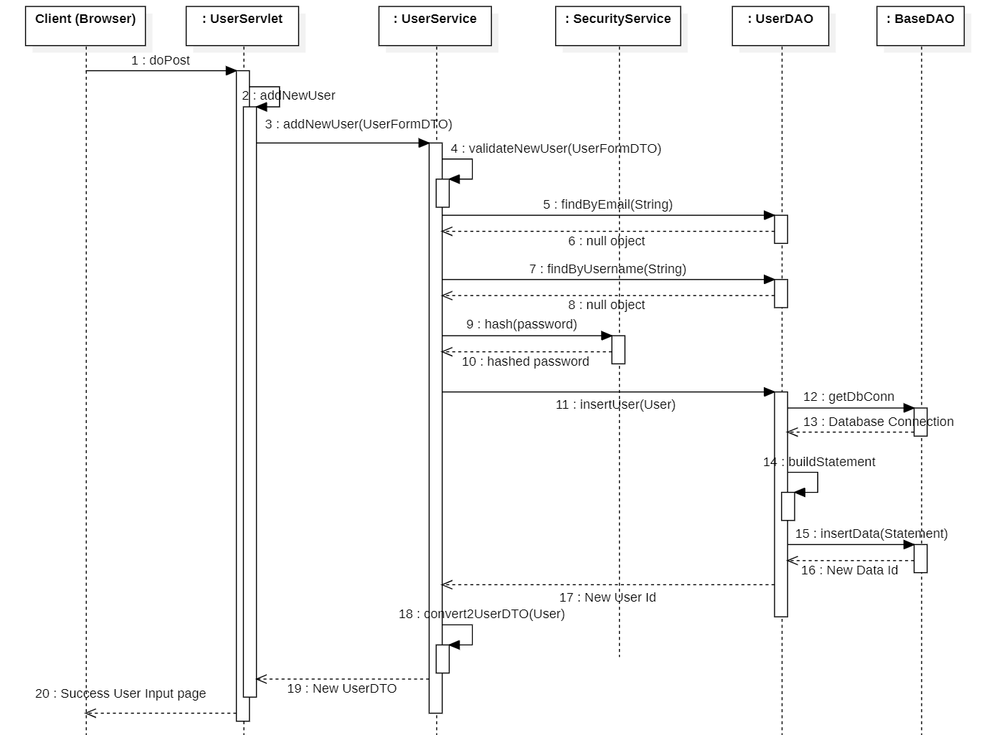

1.3 <Sequence Diagram Name2>
…

2. <Feature/Function Name2>
…

1. Location Setup and Configuration

1.1 Class Diagram
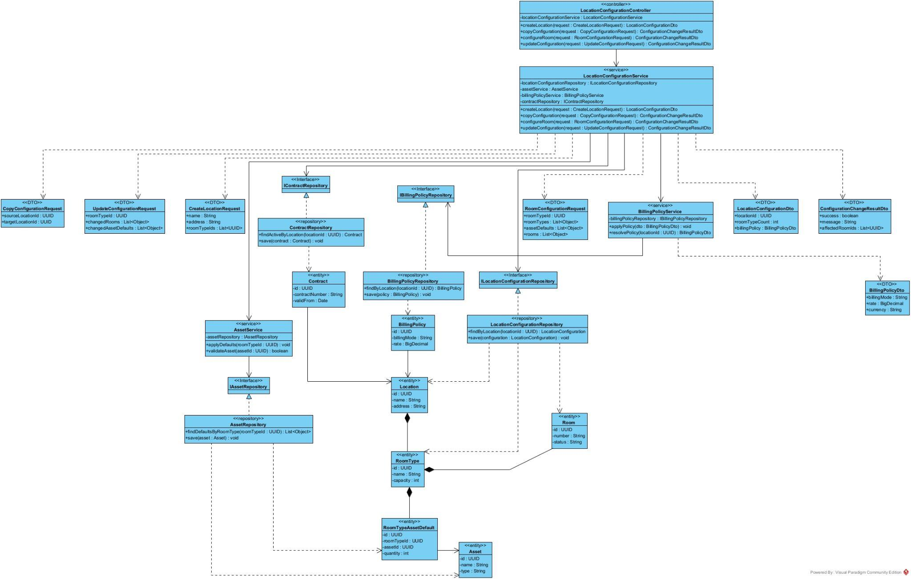

1.2 Create Location and Initial Configuration
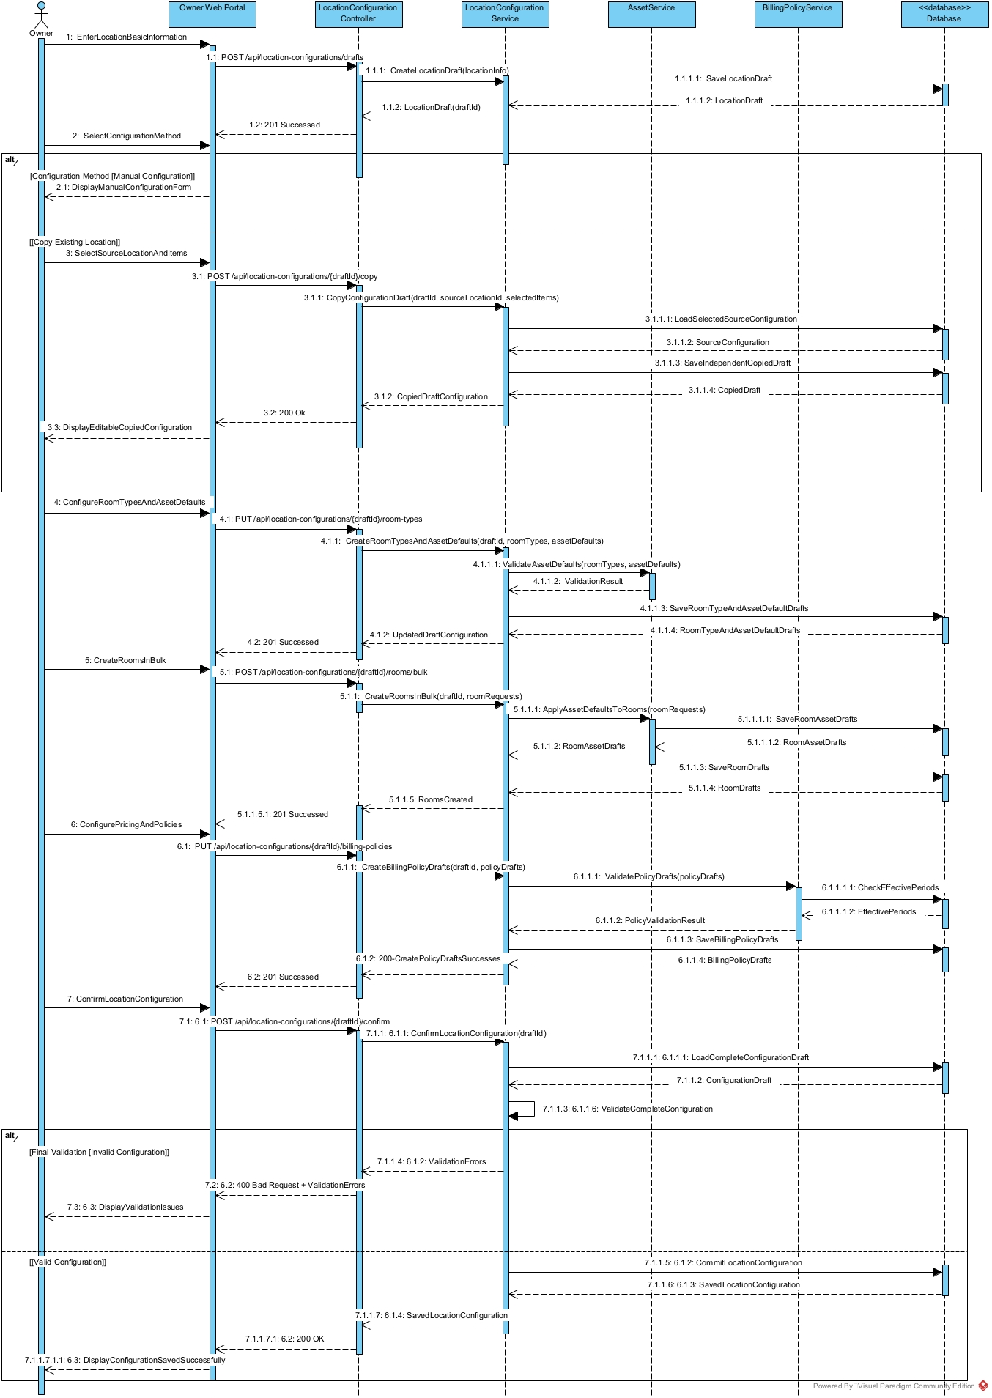

1.3 Update / Remove Location Configuration
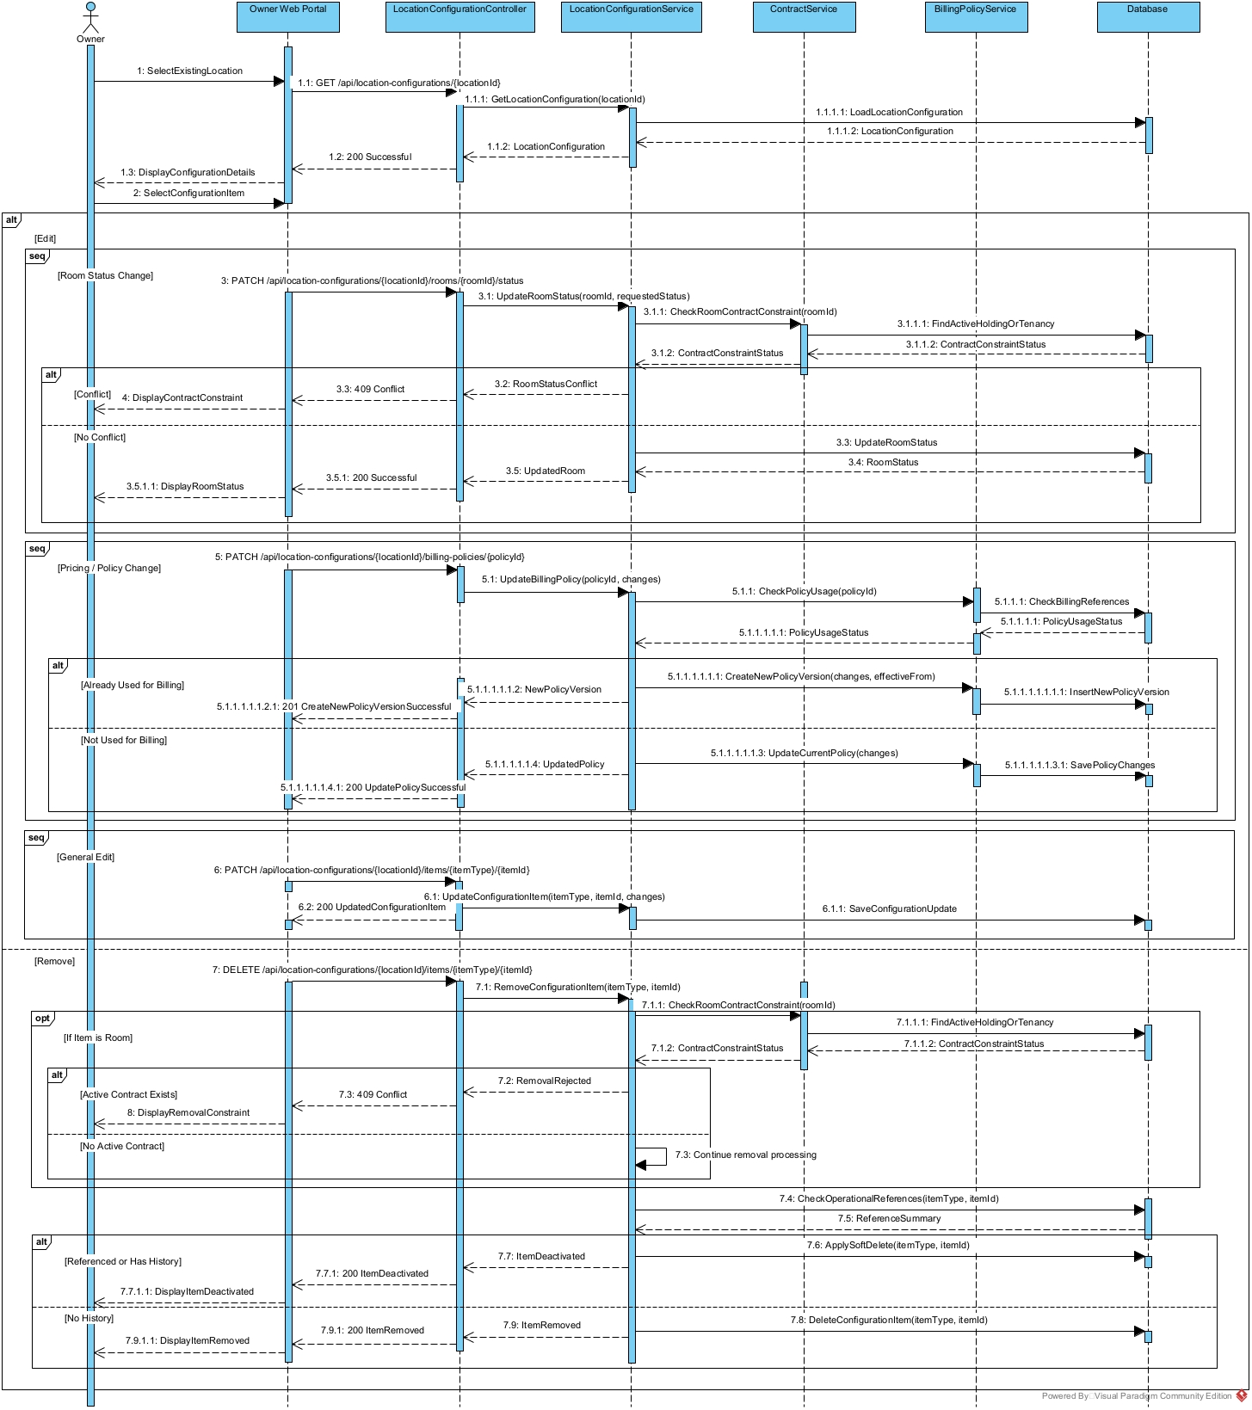

3. Main Tenancy Contract Creation and Activation

3.1 Class Diagram
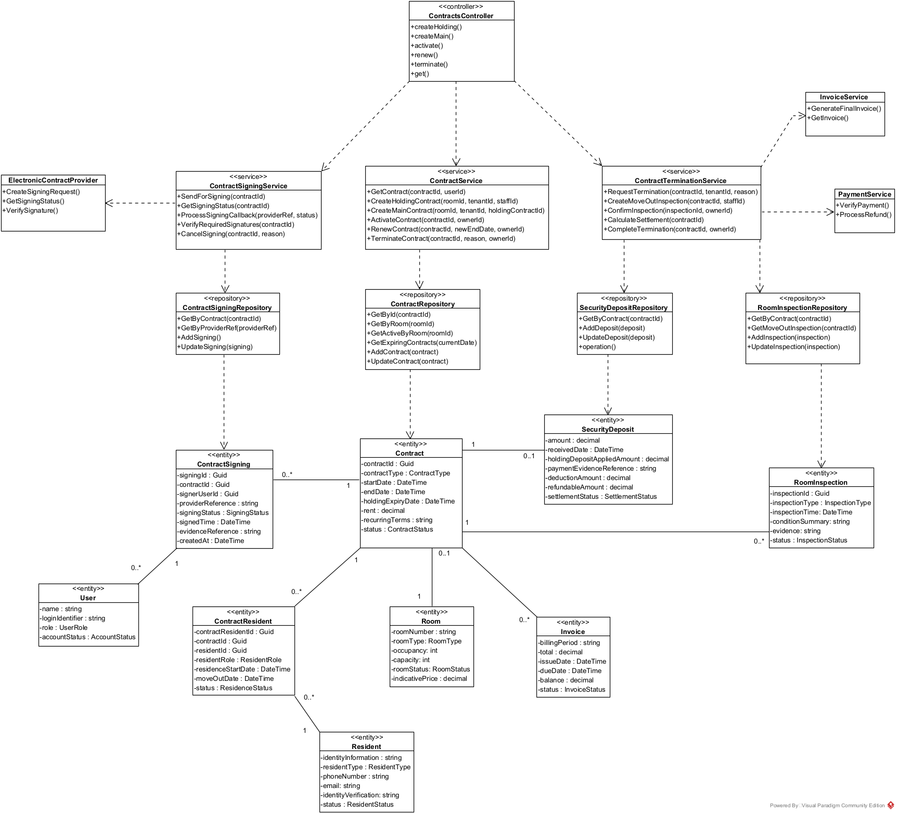

3.2 Main Tenancy Contract Creation and Activation Sequence Diagram

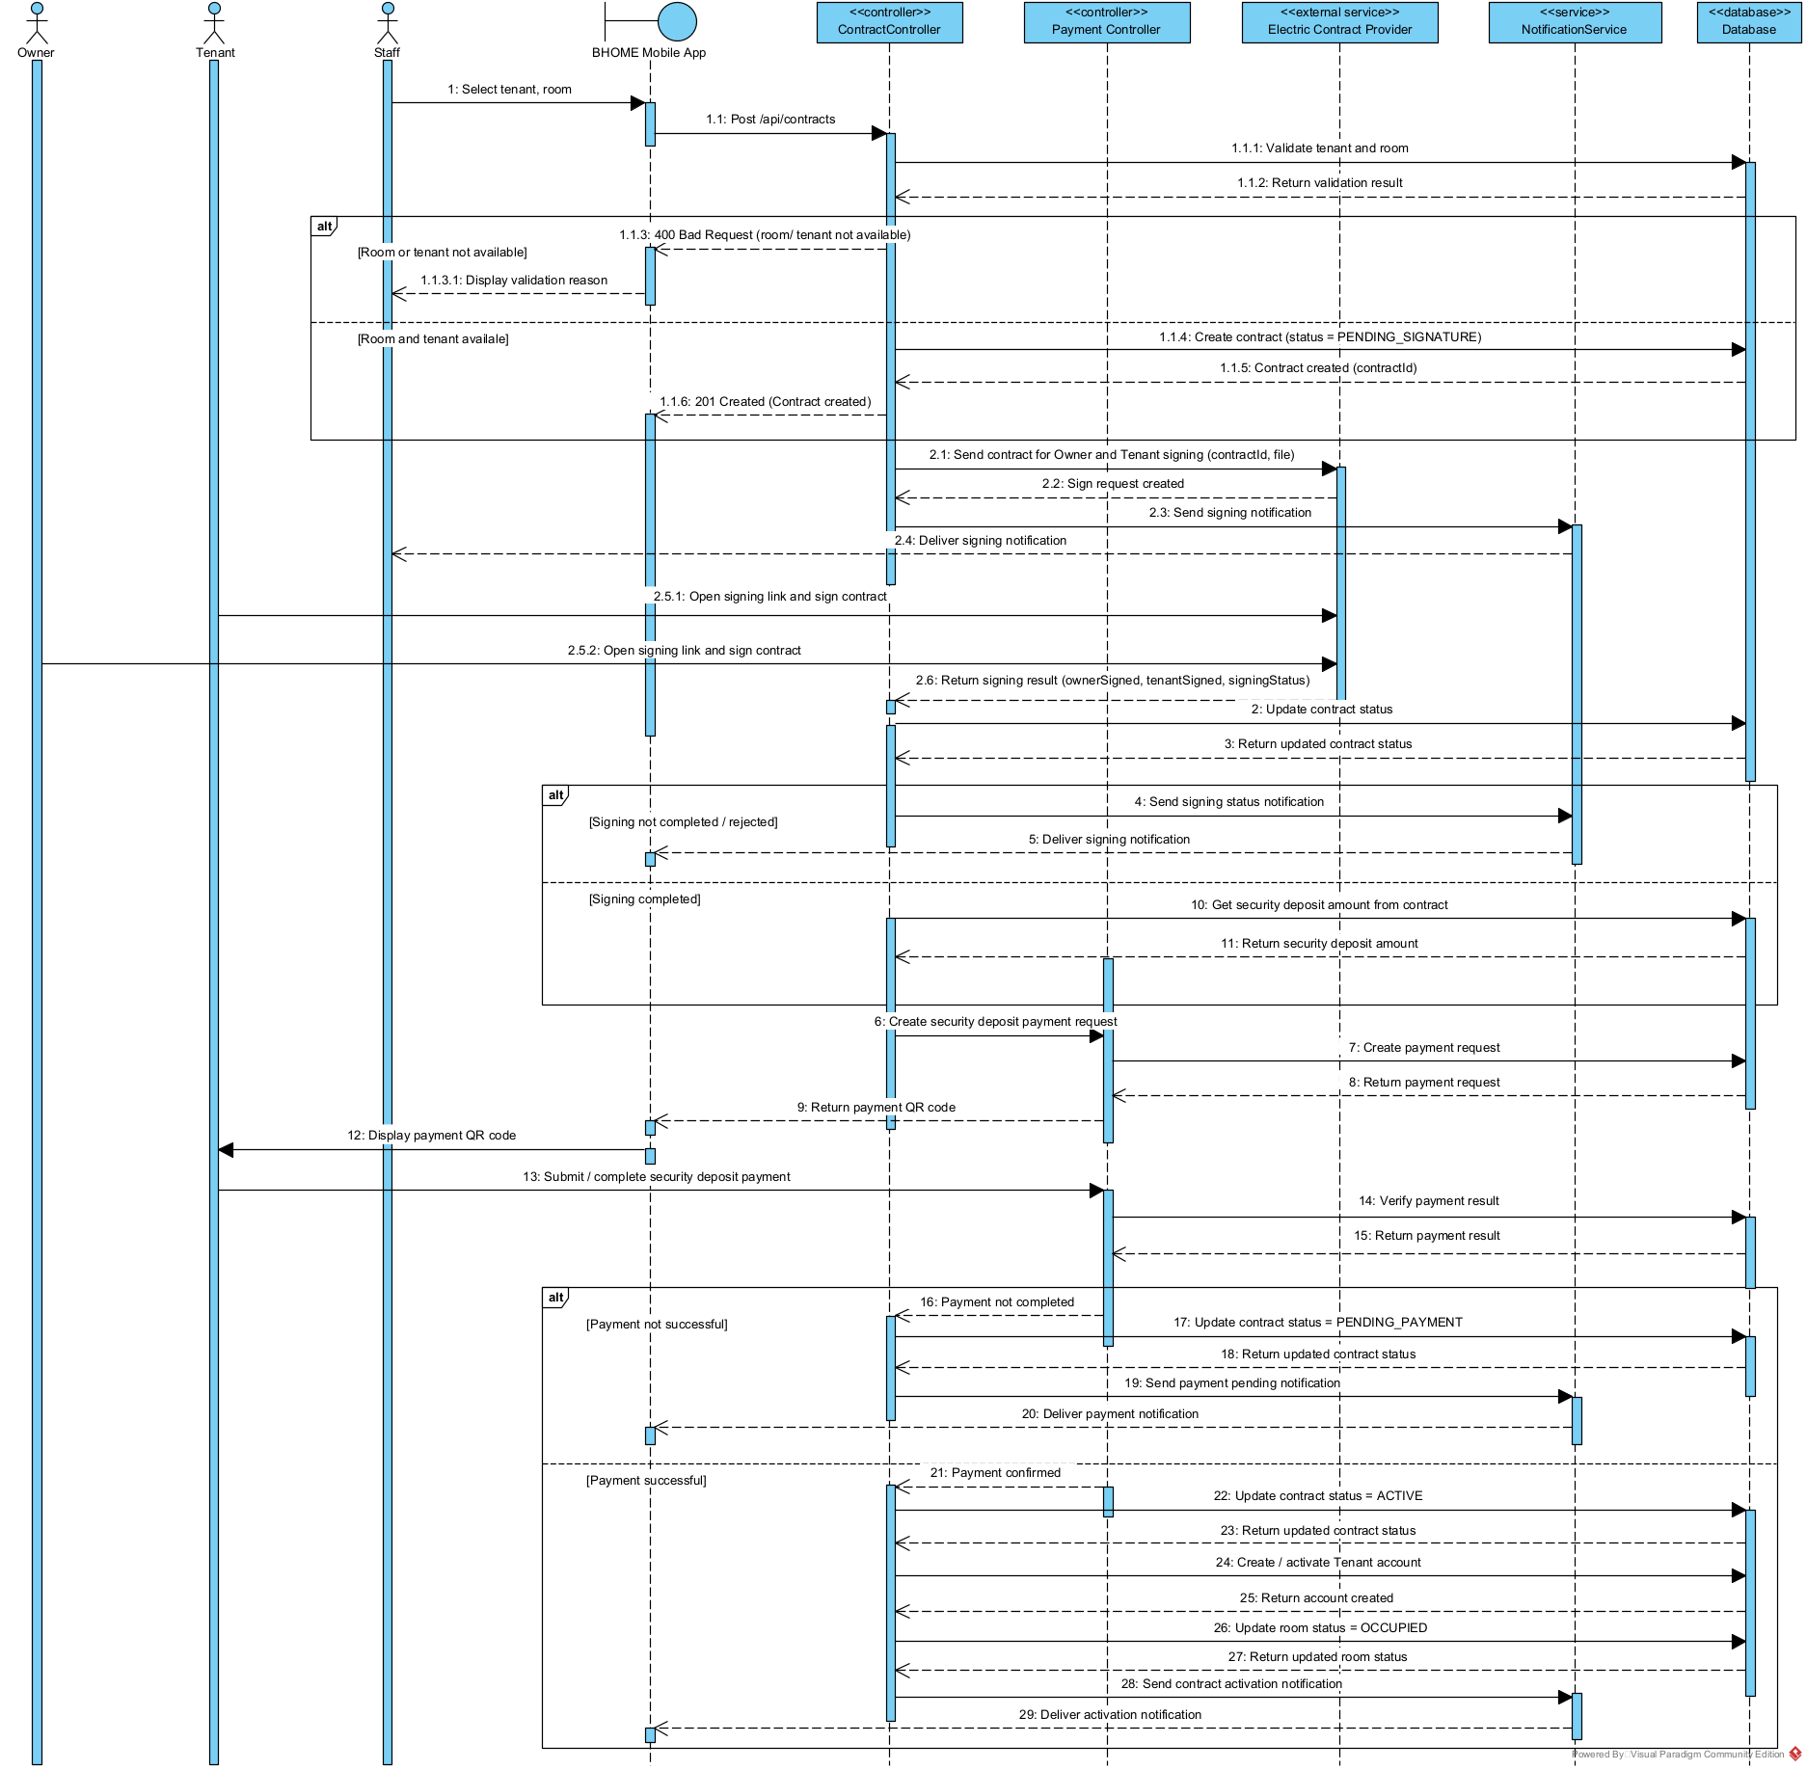

4.Contract Termination and Move-out Settlement

4.1 Contract Termination and Move-out Settlement Sequence Diagram

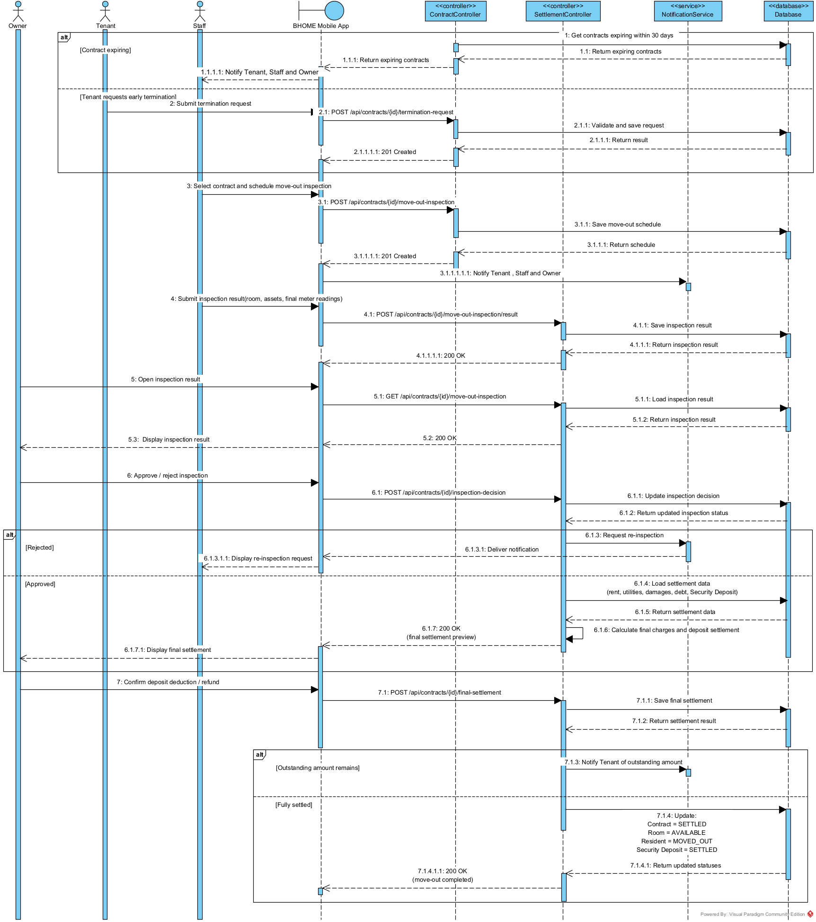

5. Meter Reading, Billing and Payment Management

5.1 Class Diagram
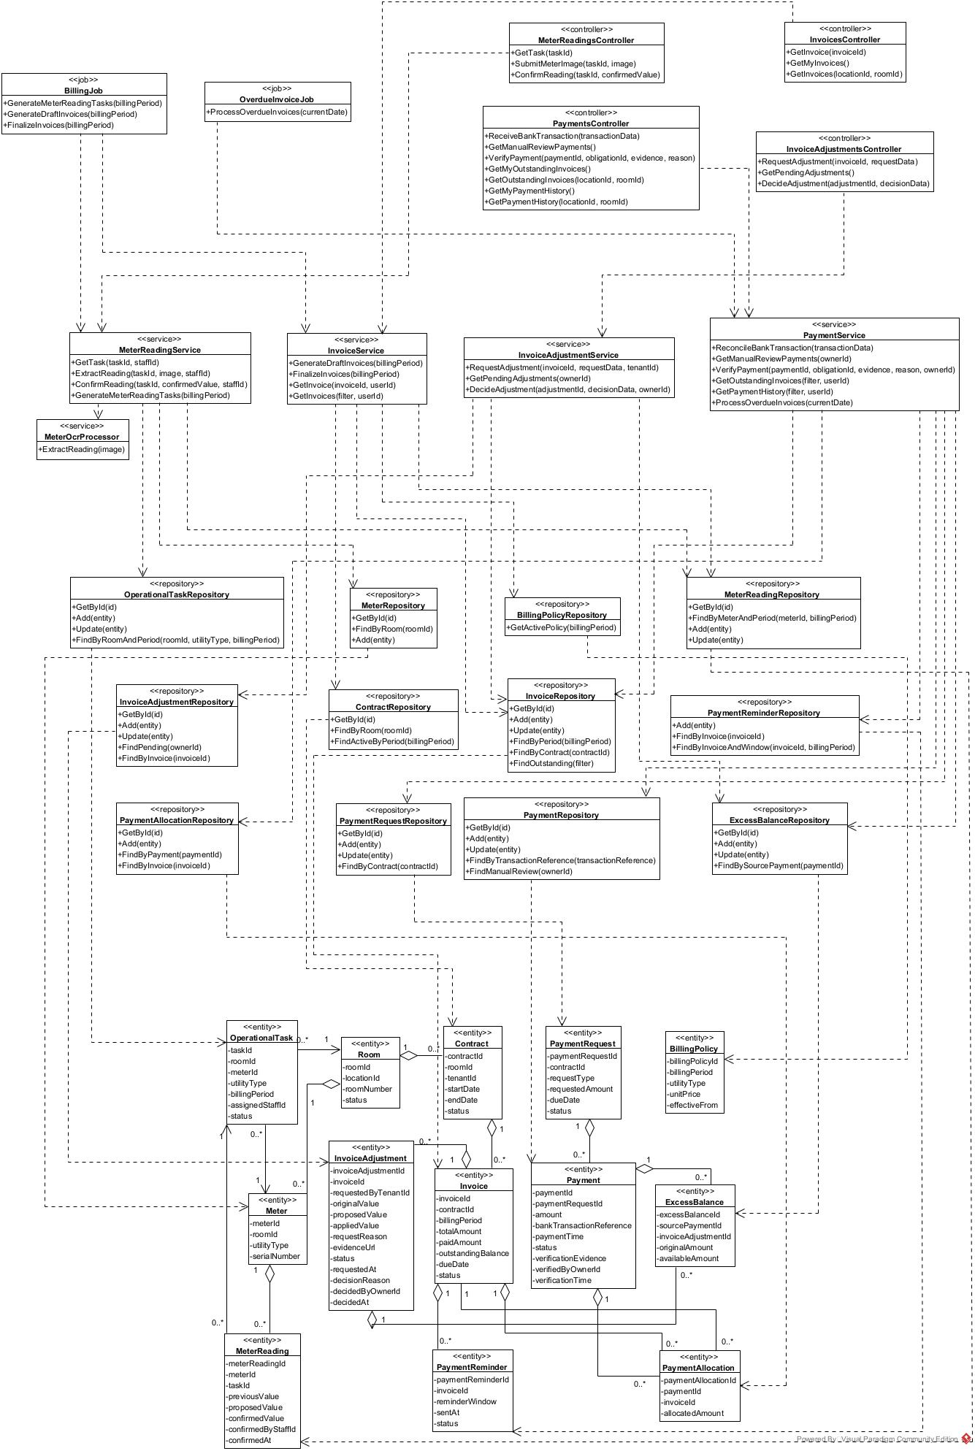

5.2 Meter Reading and Invoice Cycle Sequence Diagram
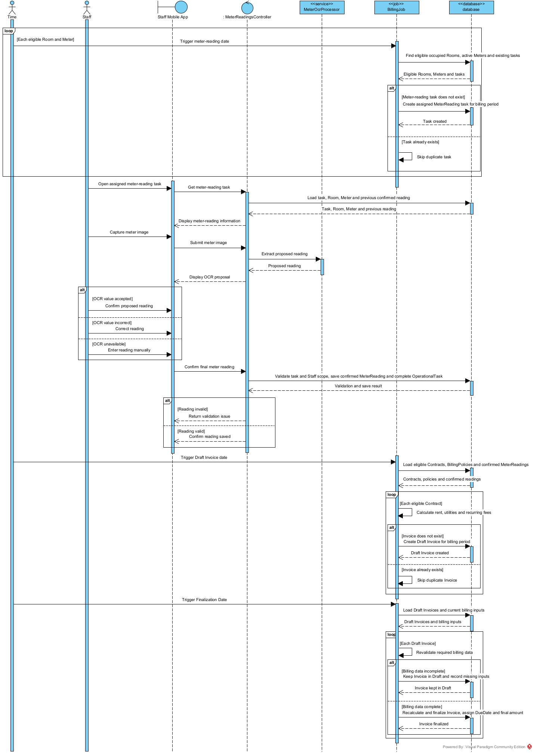

5.3 Bank Payment, Debt and Invoice Adjustment Sequence Diagram
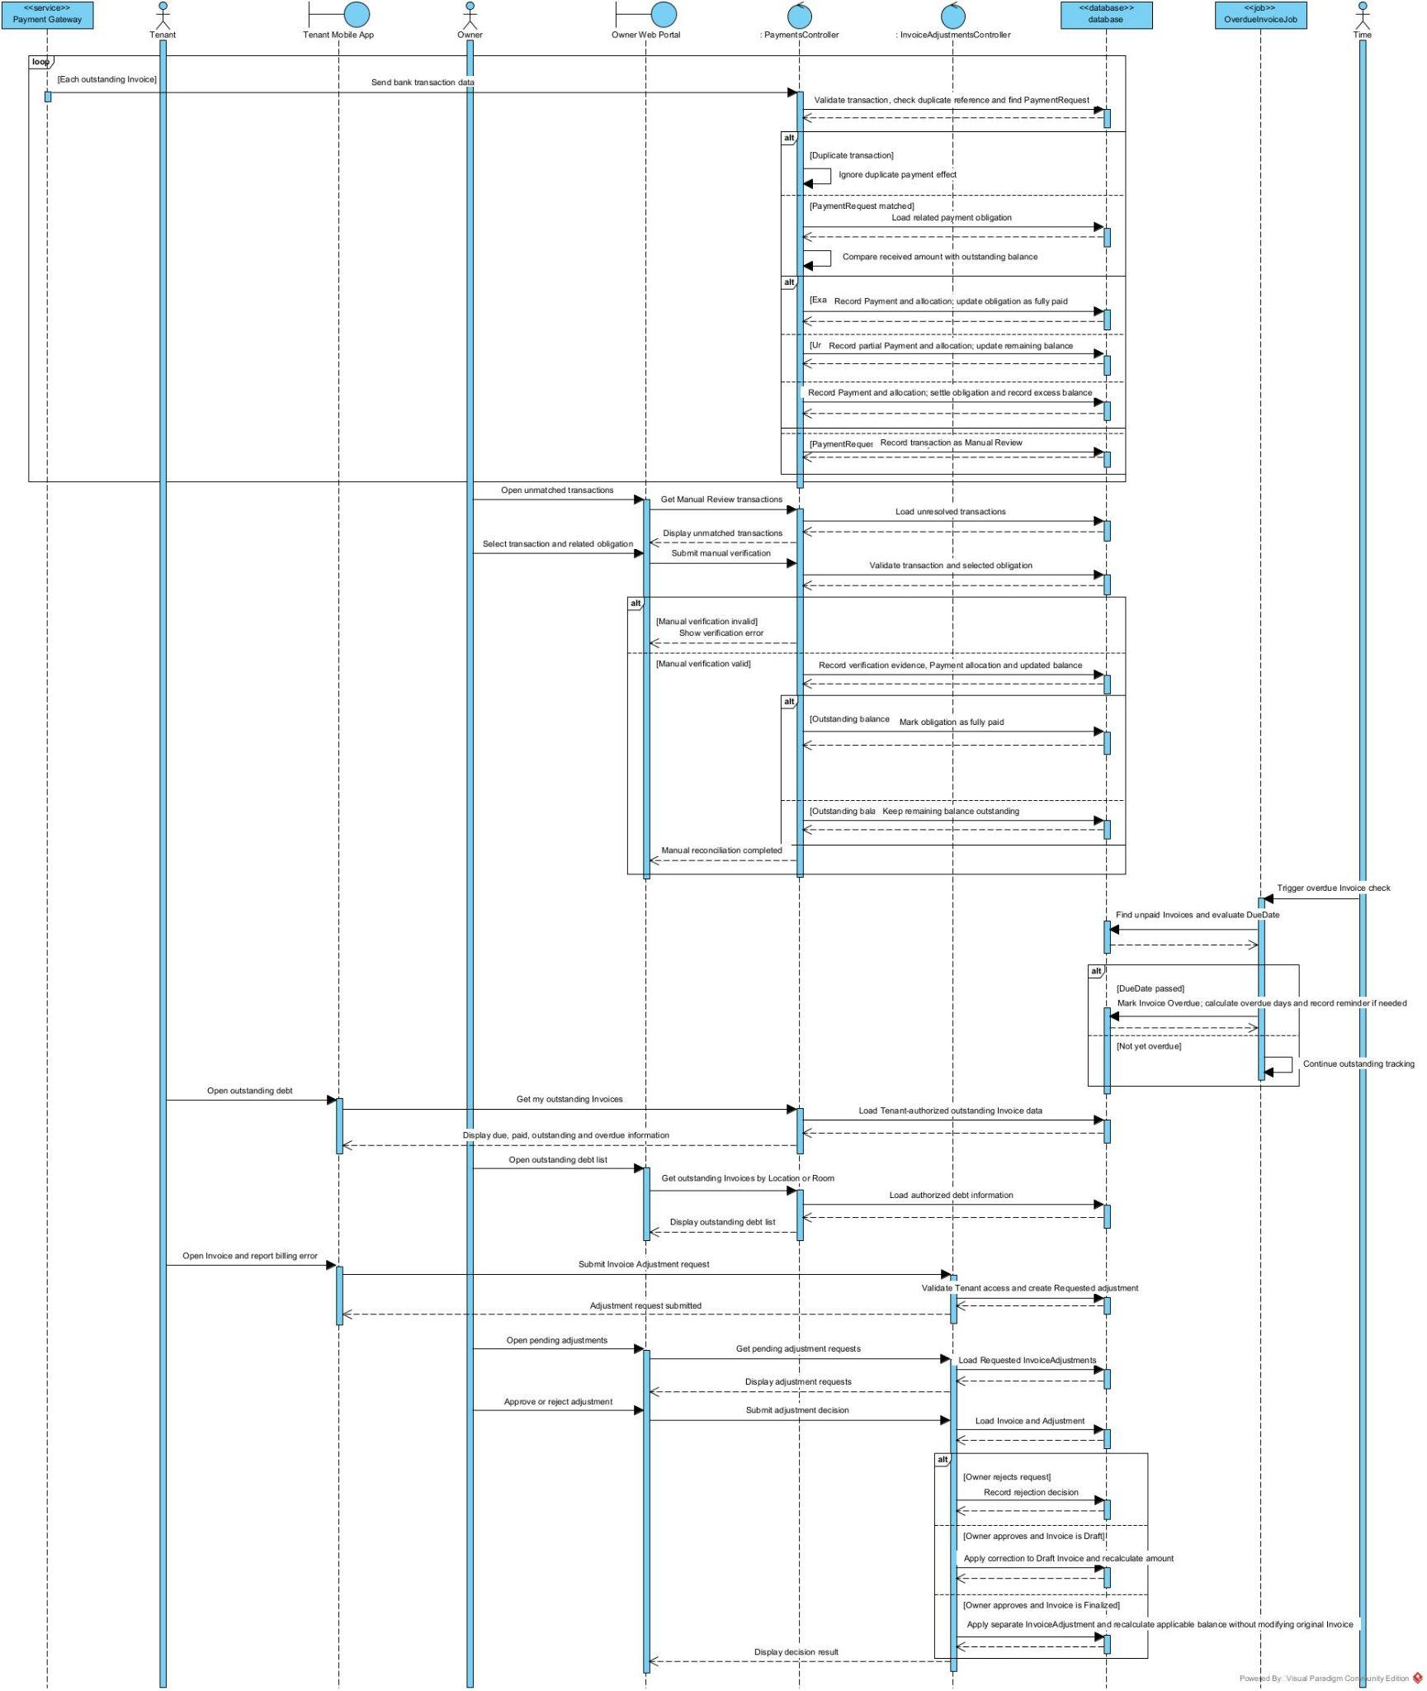

6. Incident and Maintenance Management

6.1 Class Diagram

6.1.1 Incident Reporting and Emergency Response

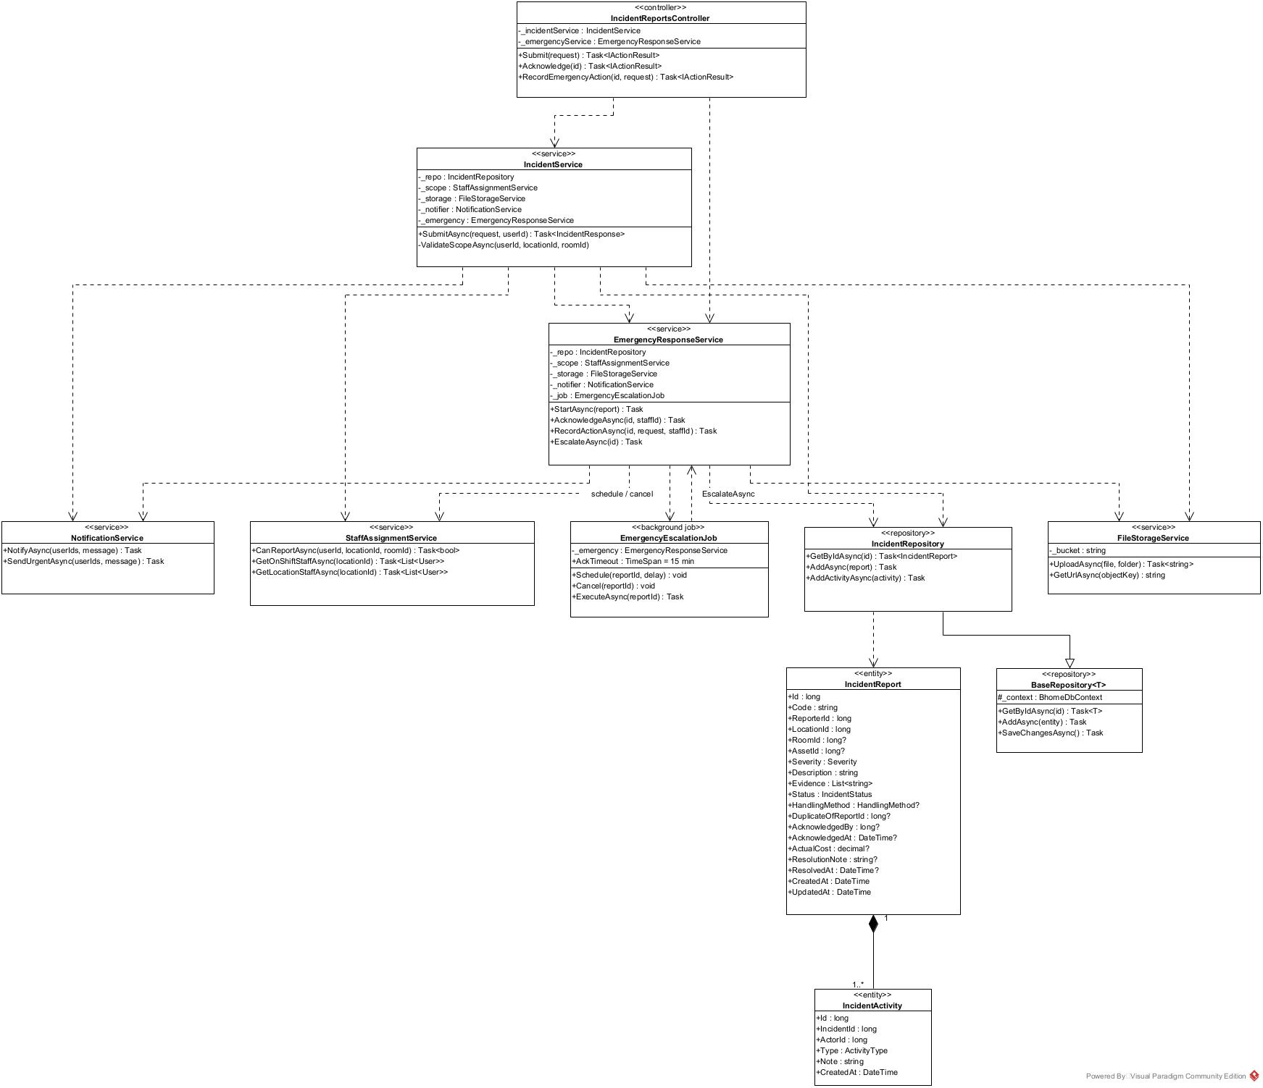

6.1.2 Maintenance Verification and Cost Recording

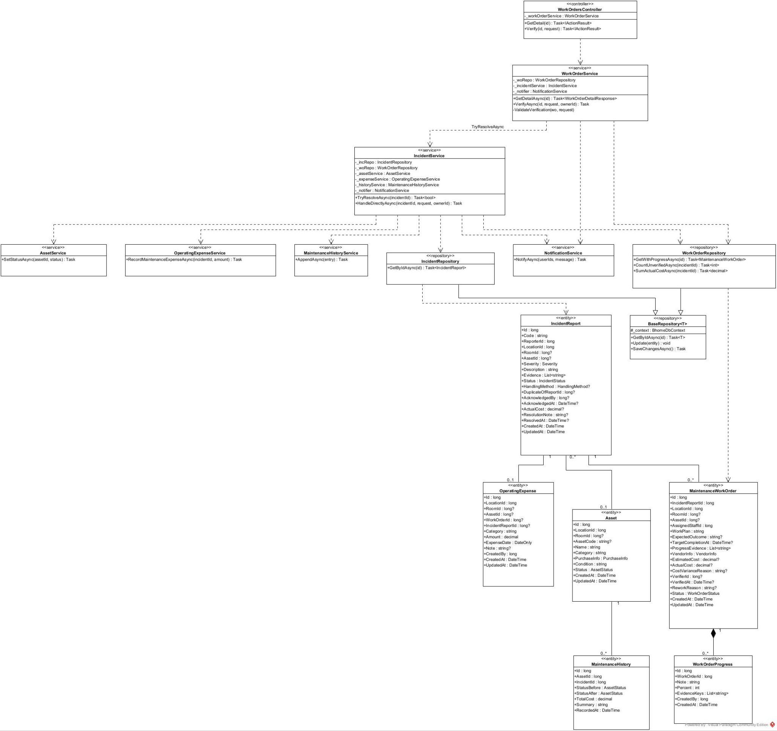

6.2 Sequence Diagram

6.2.1 Submit Incident Report

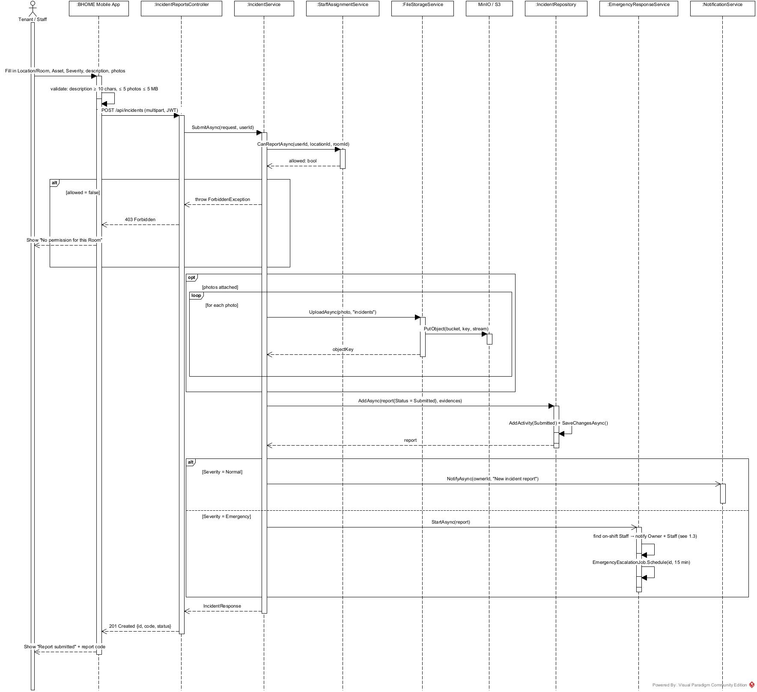

6.2.2 Acknowledge and Record Emergency Action

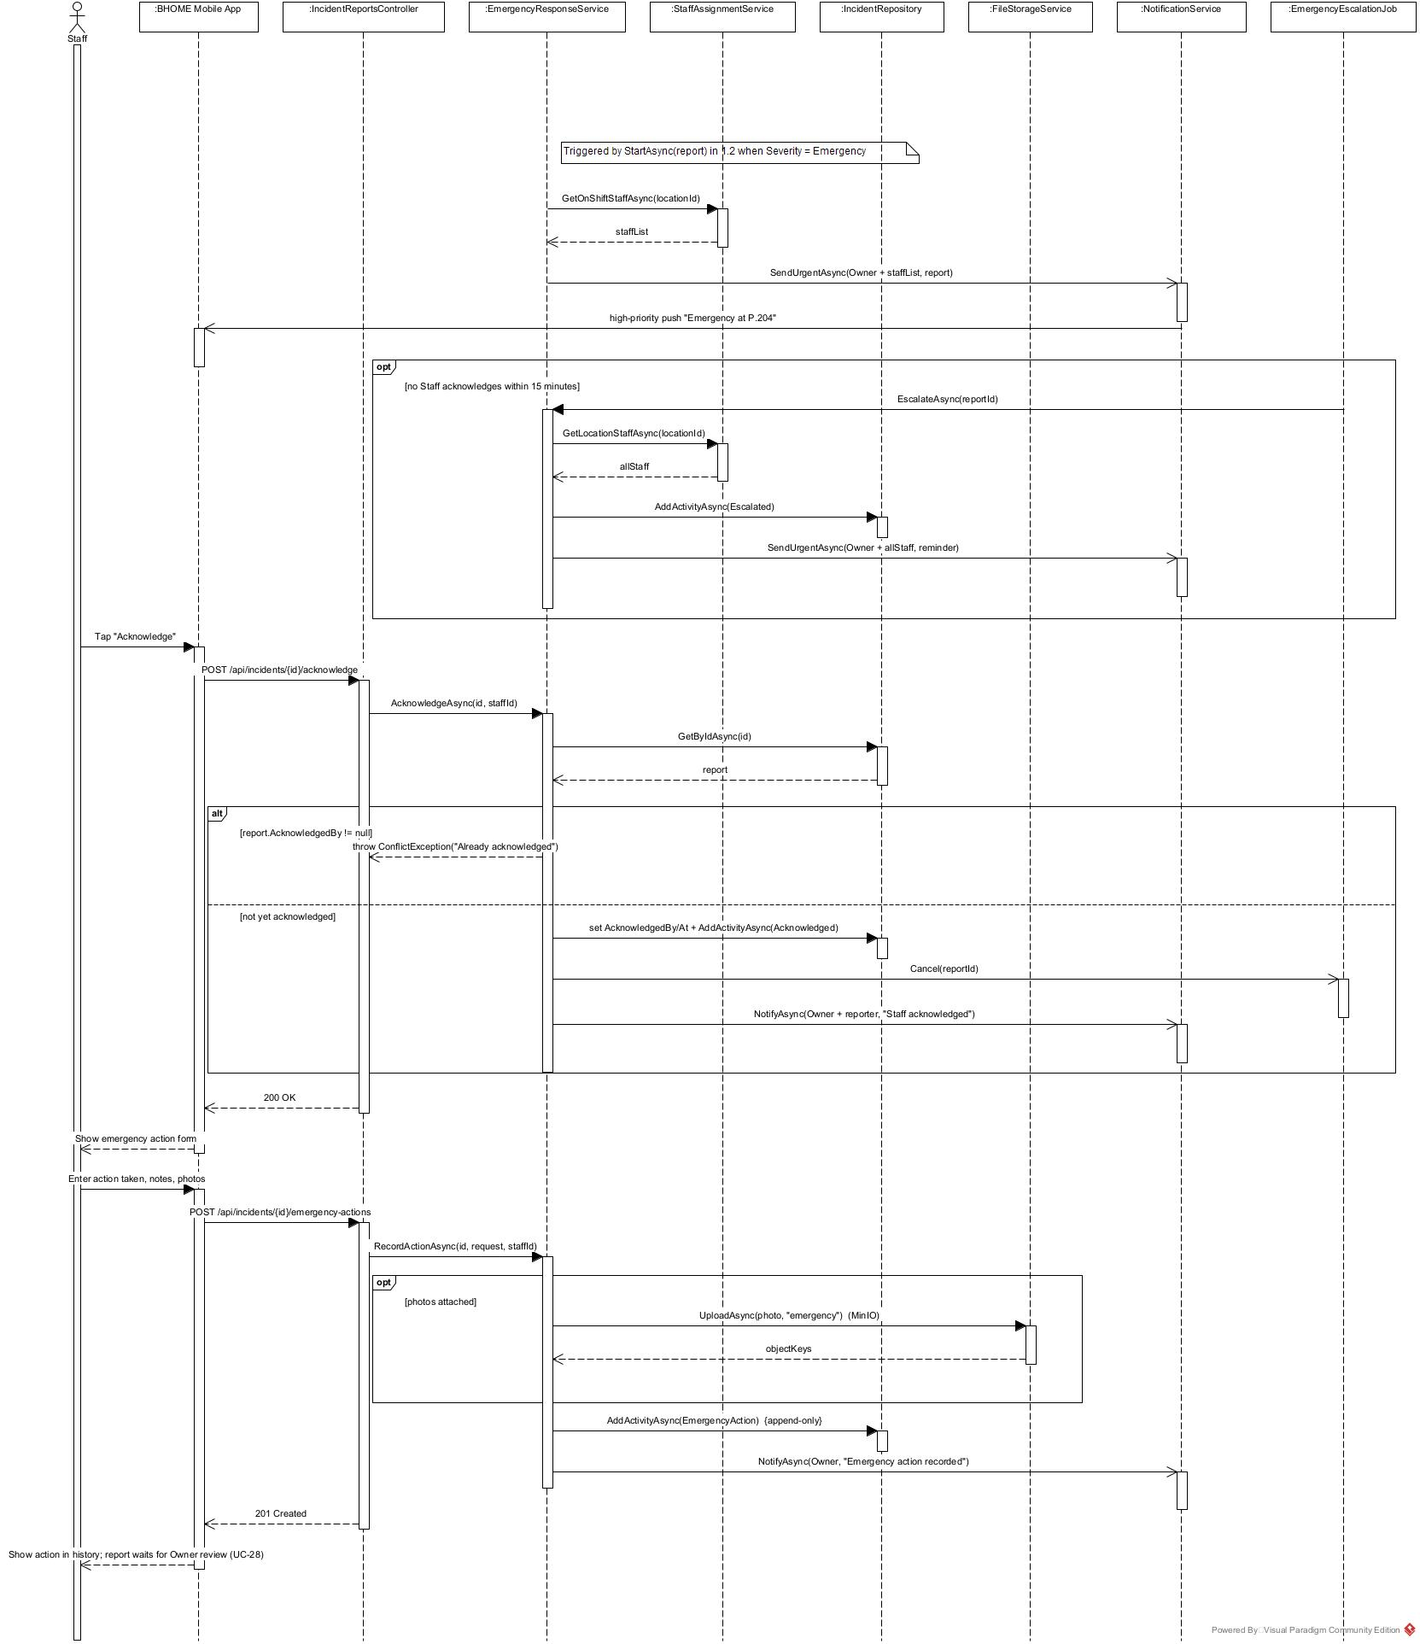

6.2.3 Verify Work Order and Resolve Incident

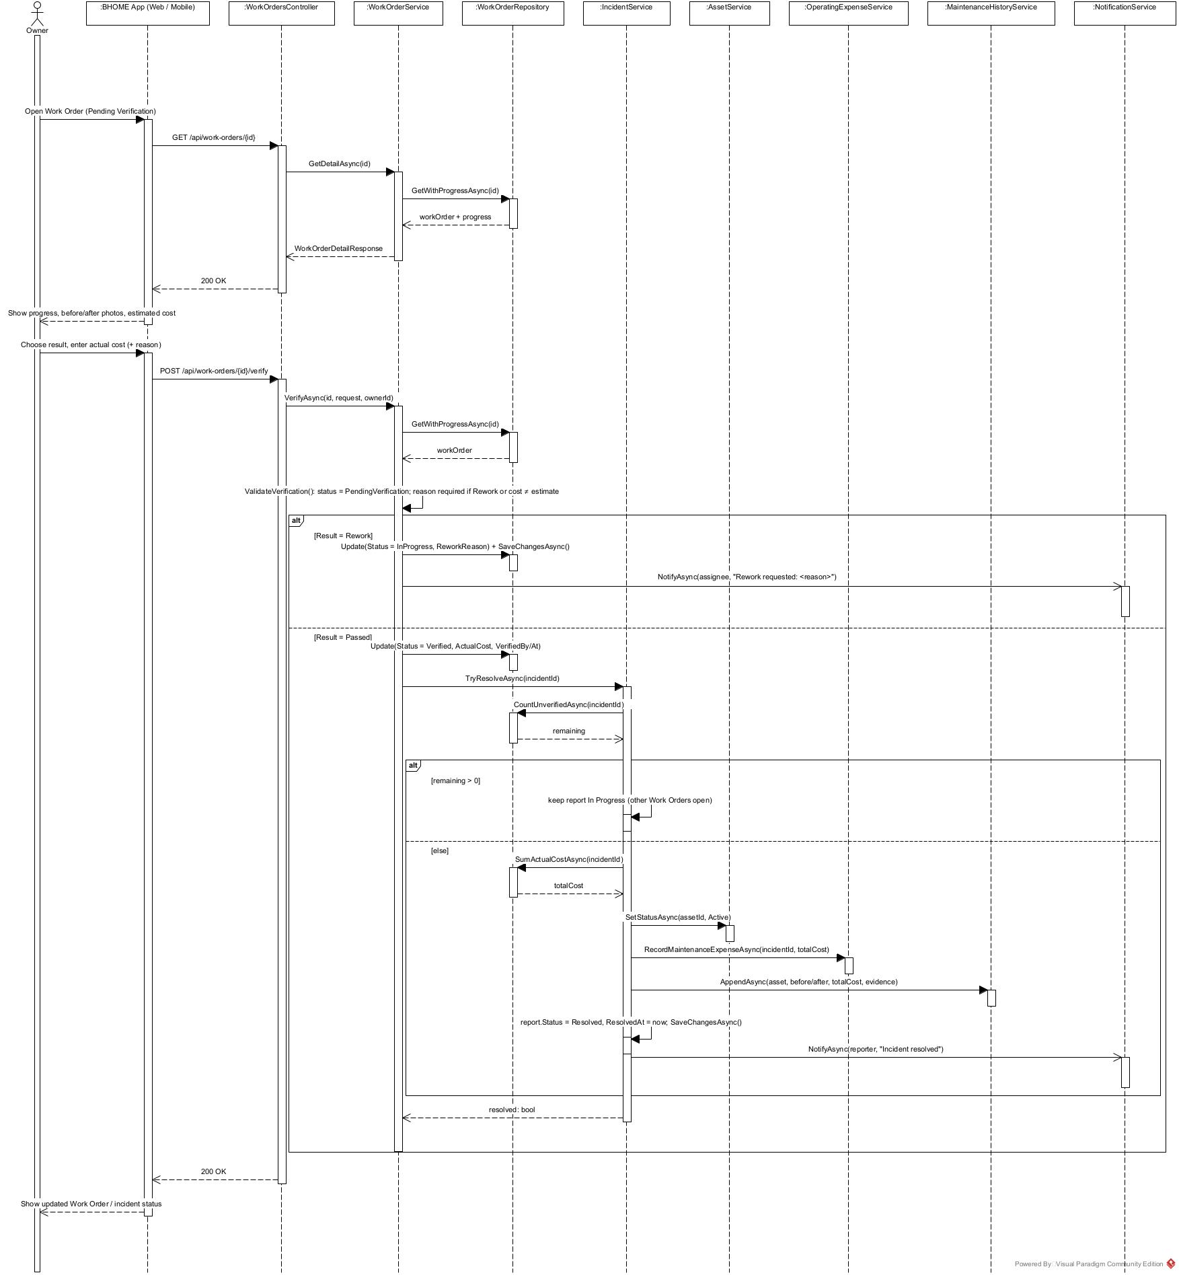

III. Design for Non-Functional Requirements

1. Security Design

1.1 Authentication Flow
BHOME uses ASP.NET Core Identity and JWT-based authentication. Owner, Staff and Tenant must sign in before accessing protected functions. After successful authentication, the API issues a JWT access token containing the user identity and role. The token is validated by ASP.NET Core authentication middleware on every protected API request.
Public Website endpoints that expose only Owner-approved public information do not require authentication.

a. Token Design

Aspect | Design Decision
Token format | JWT signed by the BHOME server (HS256); signing key of at least 256 bits loaded from an environment variable
Access token expiry | 30 minutes; configurable per environment
Refresh token expiry | 7 days; rotated on every refresh
Main claims | sub (User ID), role (Owner, Staff or Tenant), sstamp (security stamp), jti
Location scope | Not placed in the token; Staff Location assignments are checked server-side on each request (section 1.2)
Token validation | Signature, issuer, audience, expiry (clock skew 30 s) and security stamp
Server-side storage | Refresh token stored as SHA-256 hash only, per device
Mobile App storage | Refresh token in OS secure storage (Android Keystore / iOS Keychain); access token in memory only
Owner Web Portal storage | Access token in memory; refresh token in an HttpOnly, Secure, SameSite=Strict cookie limited to /api/v1/auth
Logout | Refresh token is revoked; expired access tokens are rejected

b. CORS Configuration
Only trusted BHOME web applications may call the API from browsers. Allowed origins are configured separately for each environment.
Environment | Allowed Origins | Allowed Methods | Allow Credentials | Max Age
Development | Configured localhost origins | GET, POST, PUT, PATCH, DELETE, OPTIONS | Allowed when required | Development
Staging | BHOME staging domains only | GET, POST, PUT, PATCH, DELETE, OPTIONS | Allowed | Staging
Production | BHOME production domains only | GET, POST, PUT, PATCH, DELETE, OPTIONS | Allowed | Production

1.2 Authorization & RBAC Implementation
BHOME uses fixed Role-Based Access Control with Owner, Staff and Tenant roles. Guest is a public, non-RBAC user.
Aspect | Decision
RBAC implementation | ASP.NET Core [Authorize], role policies and service-layer authorization
Owner | Chain-wide access to management, Contract, finance and operational decisions
Staff | Access only to permitted functions and assigned Locations
Tenant | Access only to their own Room, Contract, Invoice, Payment and request data
Guest | [AllowAnonymous] only for approved Public Website information
Role hierarchy | No role inheritance; each role has explicit permissions
Audit | Important Contract, financial, authorization and maintenance actions store actor and timestamp

1.3 Data Protection
Data Category | At Rest | In Transit | Notes
Passwords | Hashed by ASP.NET Core Identity | HTTPS/TLS | Plaintext passwords are never stored or logged
Tenant identity data | PostgreSQL with role-based access | HTTPS/TLS | Only required fields are returned to each role
CCCD images | Temporary processing only | HTTPS/TLS | Deleted after OCR processing; confirmed fields are retained
Contracts / evidence images | Private MinIO/S3 storage | HTTPS/TLS | Accessed only through authorized API requests
Payment information | PostgreSQL with audit history | HTTPS/TLS | Duplicate reconciliation events must not create duplicate payments
API keys / secrets | Environment variables or secret configuration | HTTPS/TLS | Never committed to source code or written to logs
Notification data | Stored only as required | HTTPS/TLS | Sensitive identity and unnecessary financial data are excluded
Database backups | Encrypted backup files in separate storage | HTTPS/TLS | Access limited to the deployment account

2. Performance & Scalability Design
BHOME is designed for the expected MVP scale while keeping the architecture simple. Normal API requests should complete within 2 seconds for at least 95% of requests, the Owner dashboard should load its initial summary within 5 seconds, and the system should support at least 100 concurrent sessions in the evaluation environment.

2.1 Caching Strategy
BHOME uses lightweight application caching for frequently read data. Financial and Contract state-changing operations are not served from stale cache.
What is Cached | Cache Key | TTL | Invalidation Trigger | NFR
Published Location / Room information | public:location:{locationId}, public:room:{roomId} | 5 min | Owner updates, publishes or unpublishes public information; Room becomes vacant or occupied | NFR-PER-01, NFR-PER-03
Owner dashboard summary | dashboard:owner:{ownerId}:{period} | 30 s | Invoice issued or adjusted, Payment confirmed, Expense recorded, Contract activated or ended | NFR-PER-02
Rental rate / fee configuration | pricing:location:{locationId} | 5 min | Owner updates rental rates, fees or billing policy | NFR-PER-01
Location and Room lookup lists | lookup:locations:{ownerId}, lookup:rooms:{locationId} | 10 min | Location or Room created, updated or archived | NFR-PER-01
Staff Location assignments | staffscope:{staffId} | 5 min | Assignment added or removed (invalidated immediately so access changes apply at once) | NFR-SEC-02, NFR-PER-01
…

2.2 Database Query Optimization
PostgreSQL queries are accessed through Entity Framework Core and optimized as follows:

Area | Design
Indexing | Add indexes to frequently searched and filtered columns such as Location, Room status, Contract status, Invoice status/due date and task deadline
Unique data | Use unique constraints for transaction references and other idempotency keys
List APIs | Use server-side filtering, sorting and pagination
Read-only queries | Use EF Core AsNoTracking() where entity updates are not required
Data loading | Load only required fields and avoid unnecessary related entities
Dashboard | Use database aggregation instead of loading all records into application memory
Transactions | Financial and Contract updates use database transactions where multiple related records must remain consistent

2.3 Background Processing
Scheduled operations such as Invoice generation, payment retries, reminders and recurring tasks run through Background Jobs instead of blocking interactive API requests.
Each retryable job uses an idempotency check so that retries cannot create duplicate Invoices, Payments, Contracts or Notifications.
Internal OCR processing should return either an OCR proposal or a manual-entry fallback state within 10 seconds under the evaluation workload.

3. Reliability & Recoverability Design

3.1 Integration Failure Handling
External service failures must not corrupt existing BHOME business data.

Component | Failure Handling
Internal OCR | Allow manual entry when OCR fails
Payment Provider | Retry reconciliation; Owner can manually verify unmatched transactions
Notification Service | Keep in-app notification and retry external delivery
Electronic Contract Provider | Keep Contract in Pending Signing until signing succeeds
MinIO / S3 Object Storage | A failed upload aborts the business transaction, so no record points to a missing file
Background Jobs | Log failure and retry or move the item to an explicit review state

3.2 Data Consistency & Recovery

Aspect | Design Decision
Financial consistency | Invoice, Payment, Debt, Deposit and Adjustment updates use controlled transactions
Idempotency | Duplicate external events and job retries do not create duplicate business effects
Failure logging | Failed jobs and external calls are recorded for review
Database backup | Daily PostgreSQL backup
Recovery Point Objective | RPO: 24 hours
Recovery Time Objective | RTO: 8 hours
File upload | Incident evidence supports up to 5 images, maximum 5 MB per image

4. Privacy & Test Data Design

Area | Design Decision
Test data | Use synthetic, mock or anonymized Tenant data for development and testing
CCCD OCR | CCCD images are temporary inputs and are deleted after processing
Stored identity data | Store only Staff-confirmed identity fields and required verification metadata
API responses | Return only information required by the current role and workflow
Logging | Sensitive identity, credentials and financial data are excluded from unrestricted logs
Notifications | Do not include unnecessary sensitive identity or financial information
Public Website | Expose only Owner-approved non-sensitive Location and Room information
Former Tenants | After a Contract ends, the Tenant keeps read-only access to their own Contract, Invoices and payment history; Staff loses access to their identity data

5. Usability Design
BHOME follows a mobile-first design for Owner monitoring, Staff operations and Tenant self-service.

Aspect | Design Decision
UI language | Vietnamese for MVP
Currency | VND, thousands separator, no decimals
Time zone | Asia/Ho_Chi_Minh (UTC+7); stored in UTC, displayed in local time
Date format | dd/MM/yyyy
OCR confirmation | OCR-proposed values are visually distinguished from confirmed values until Staff confirms them
Error messages | Clearly explain the required corrective action without exposing sensitive data (section 3.3)
Manual fallback | Manual Meter/CCCD entry and manual payment verification remain available when automated processing fails (NFR-USA-02)
Emergency reporting | Emergency severity is selectable in one step on the report screen; the app shows the life-safety hotline for fire, gas leak or injury
Direct handling | The Owner can record actual cost and verify an incident directly on mobile without creating a Work Order for Staff
Destructive actions | Contract termination, Invoice adjustment and Work Order rejection require a confirmation step with a reason
Terminology | Owner, Staff, Tenant and Guest terminology is used consistently throughout the system

IV. Other Design Specifications

